Which statements about sealed classes are correct?

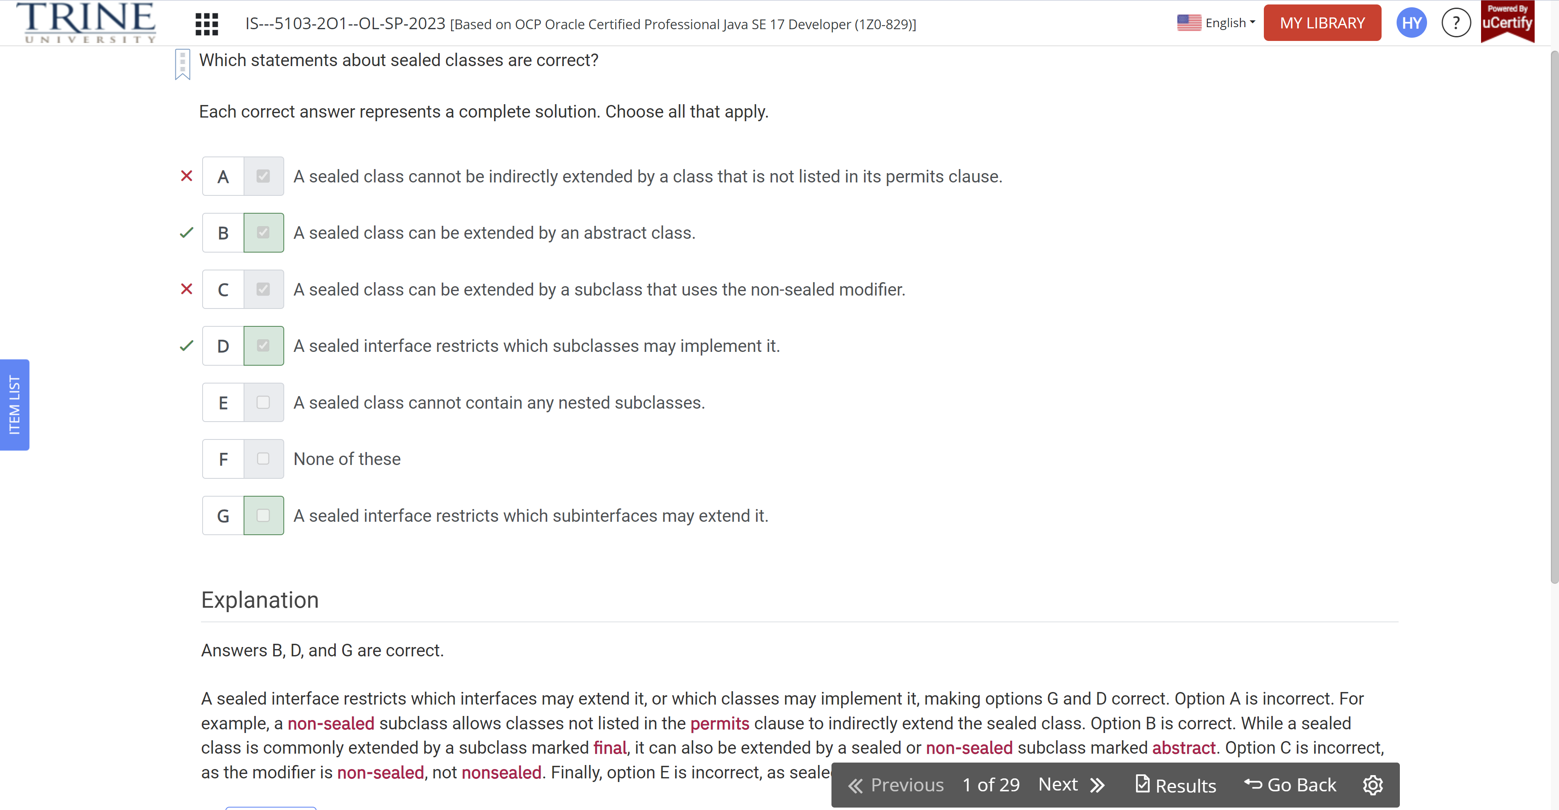

What is the output of the following program?

Interface Aquatic

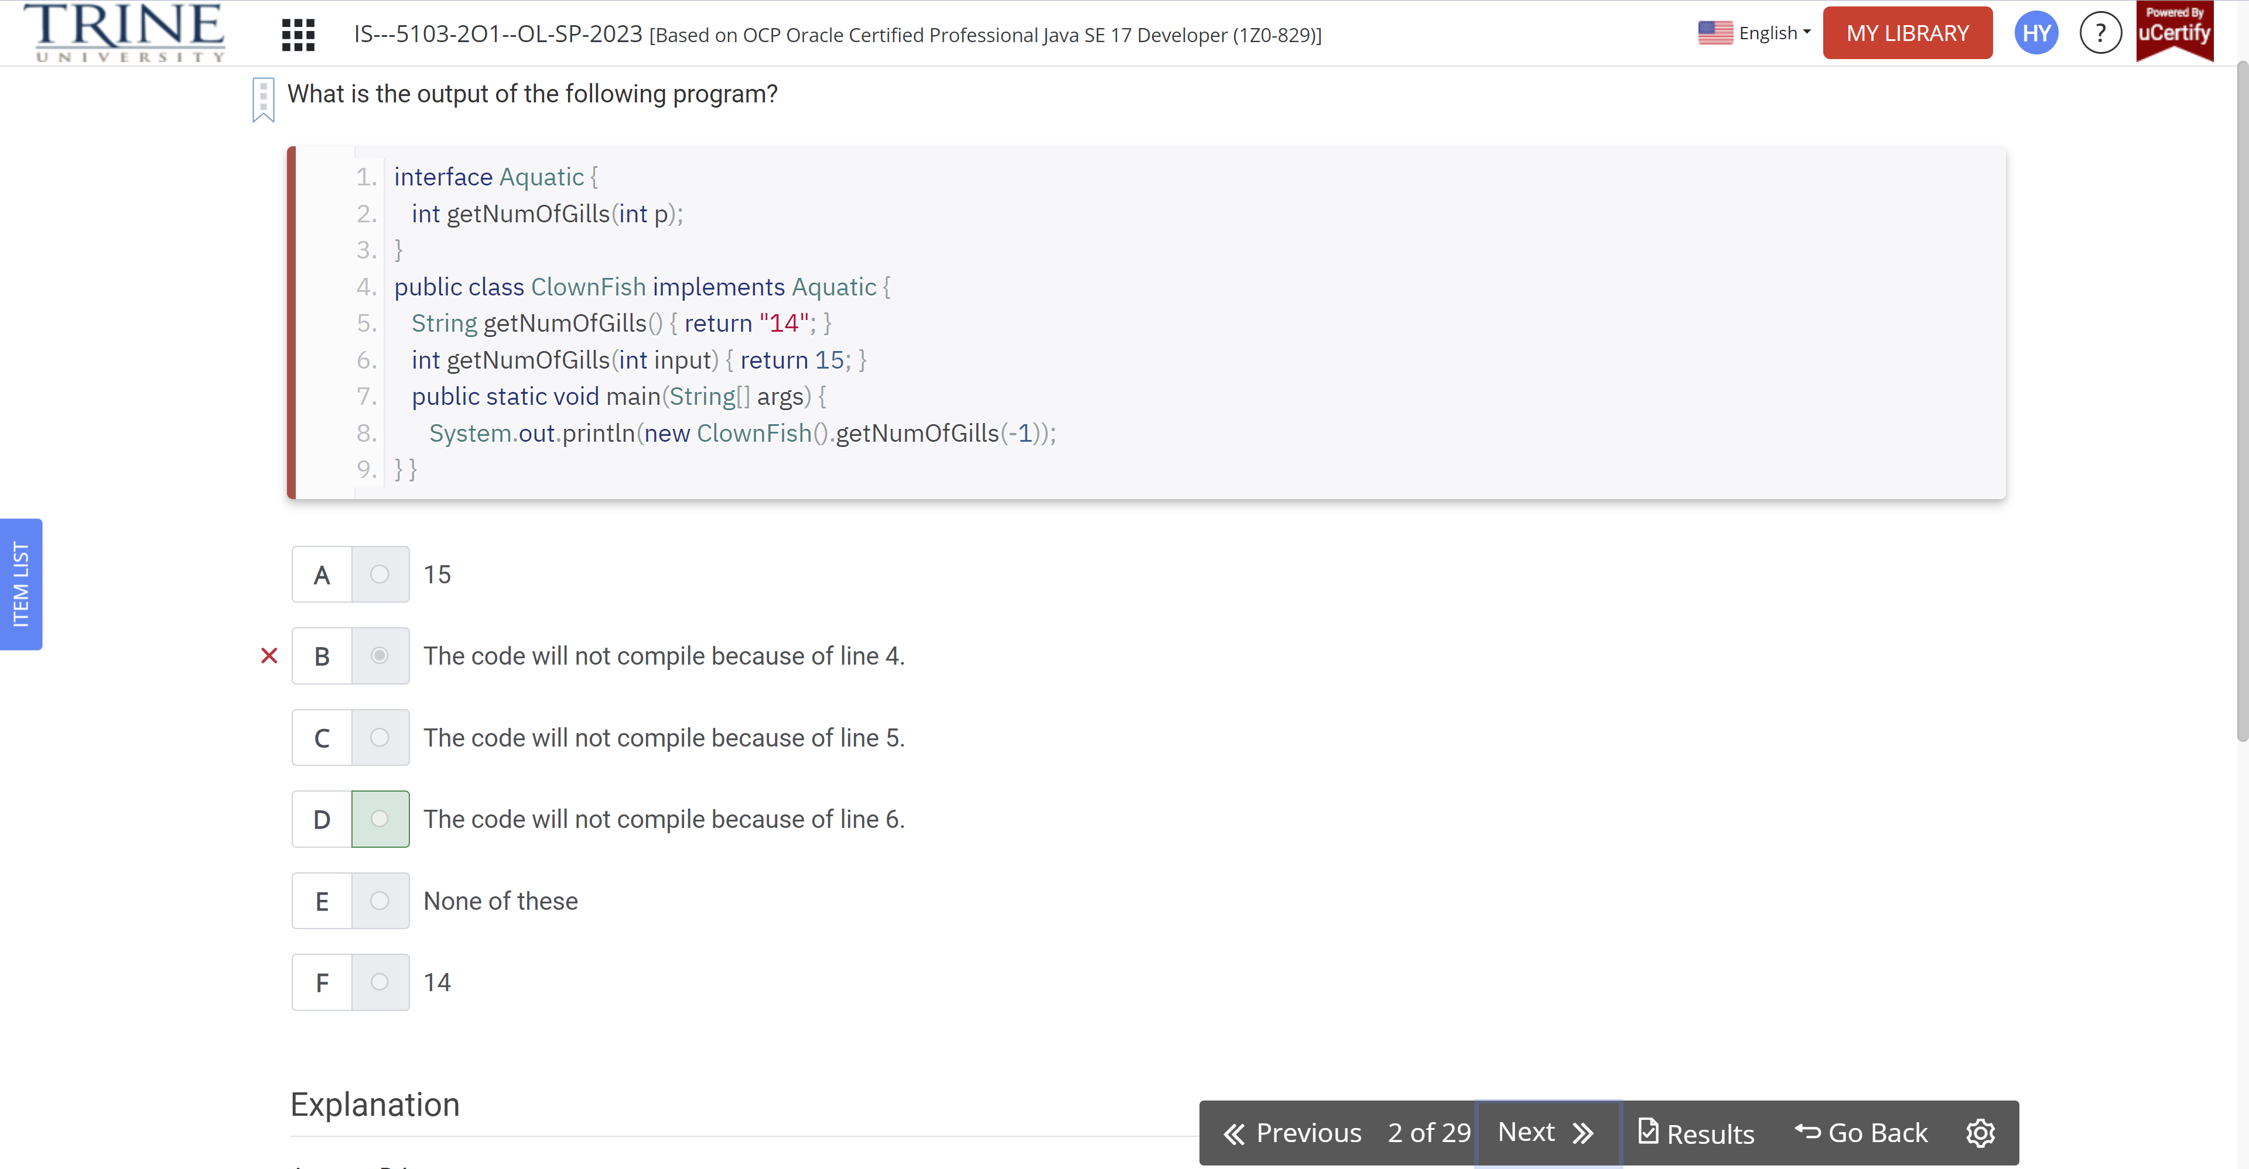

Which of the following are valid record declarations?

Public record Iguana(int age)…

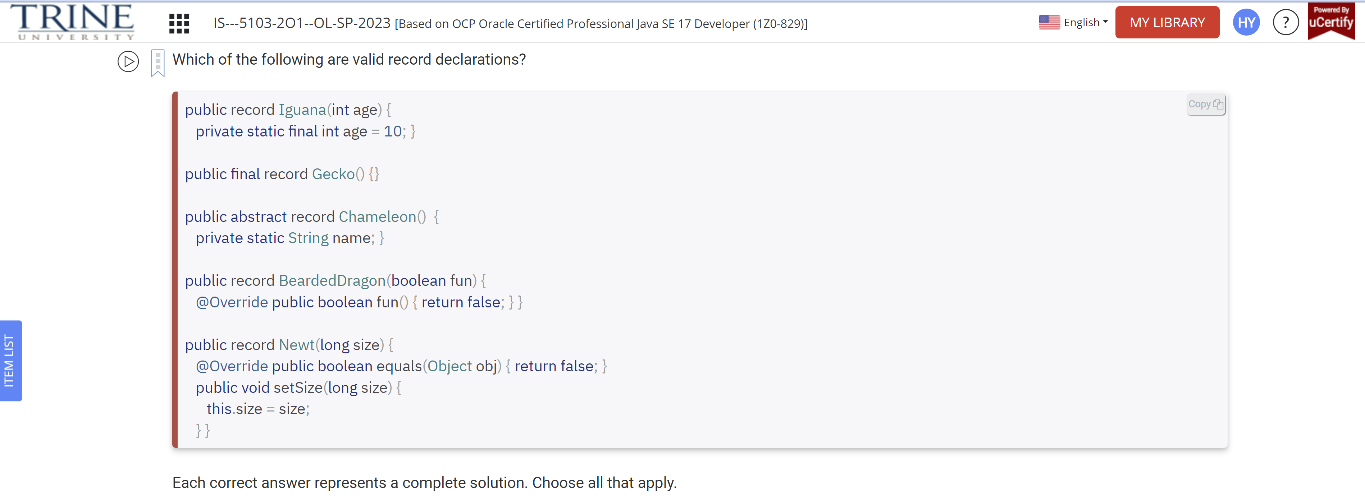

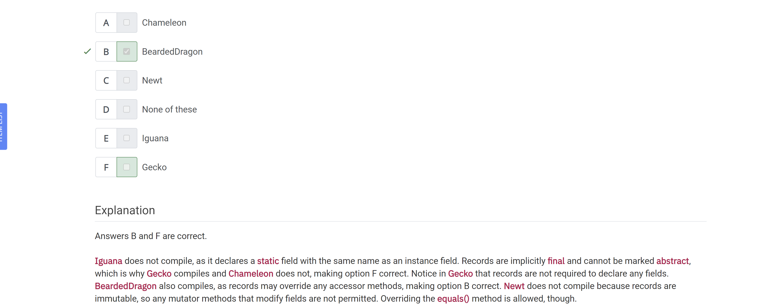

Assuming a record is defined with at least one field…

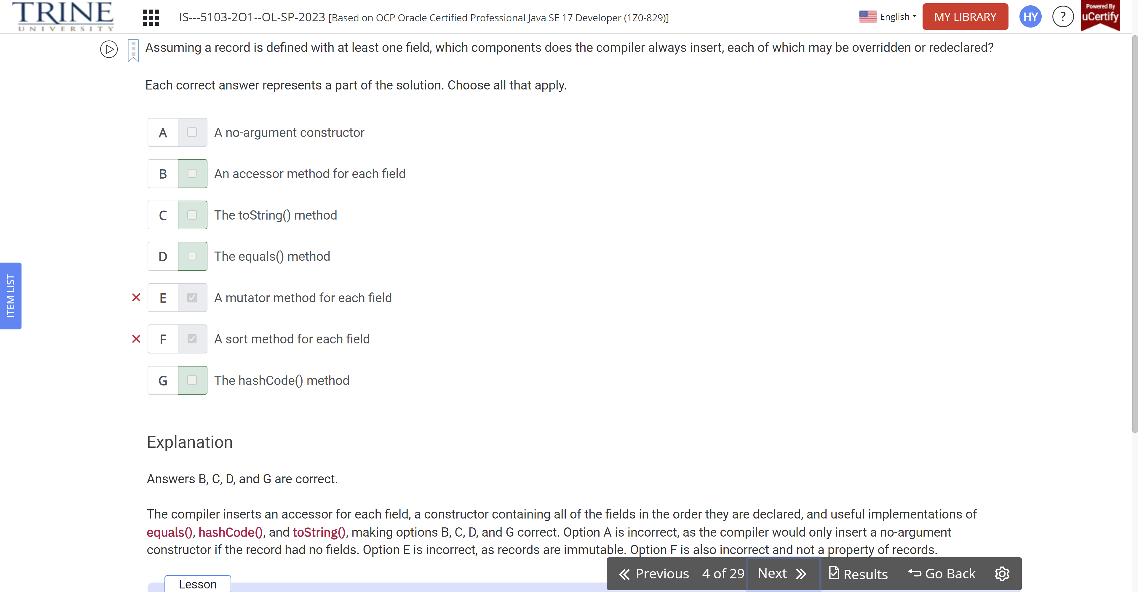

Which lines of the following interface declarations do not compile?

Public interface Omnivore…

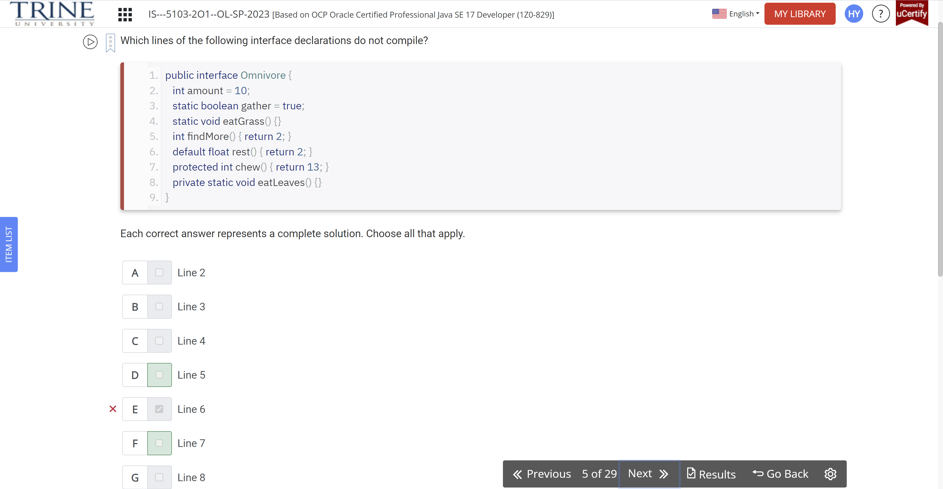

Which statements about the following program are correct?

Public abstract interface Herbivore…

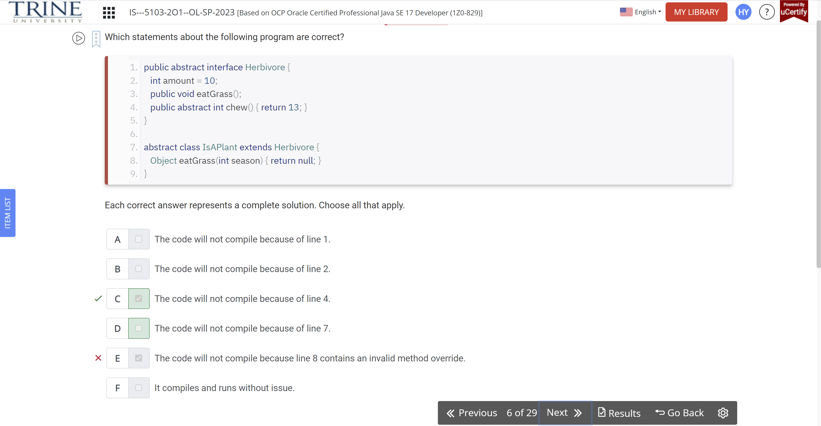

What is the result of the following program?

Public class Favorites…

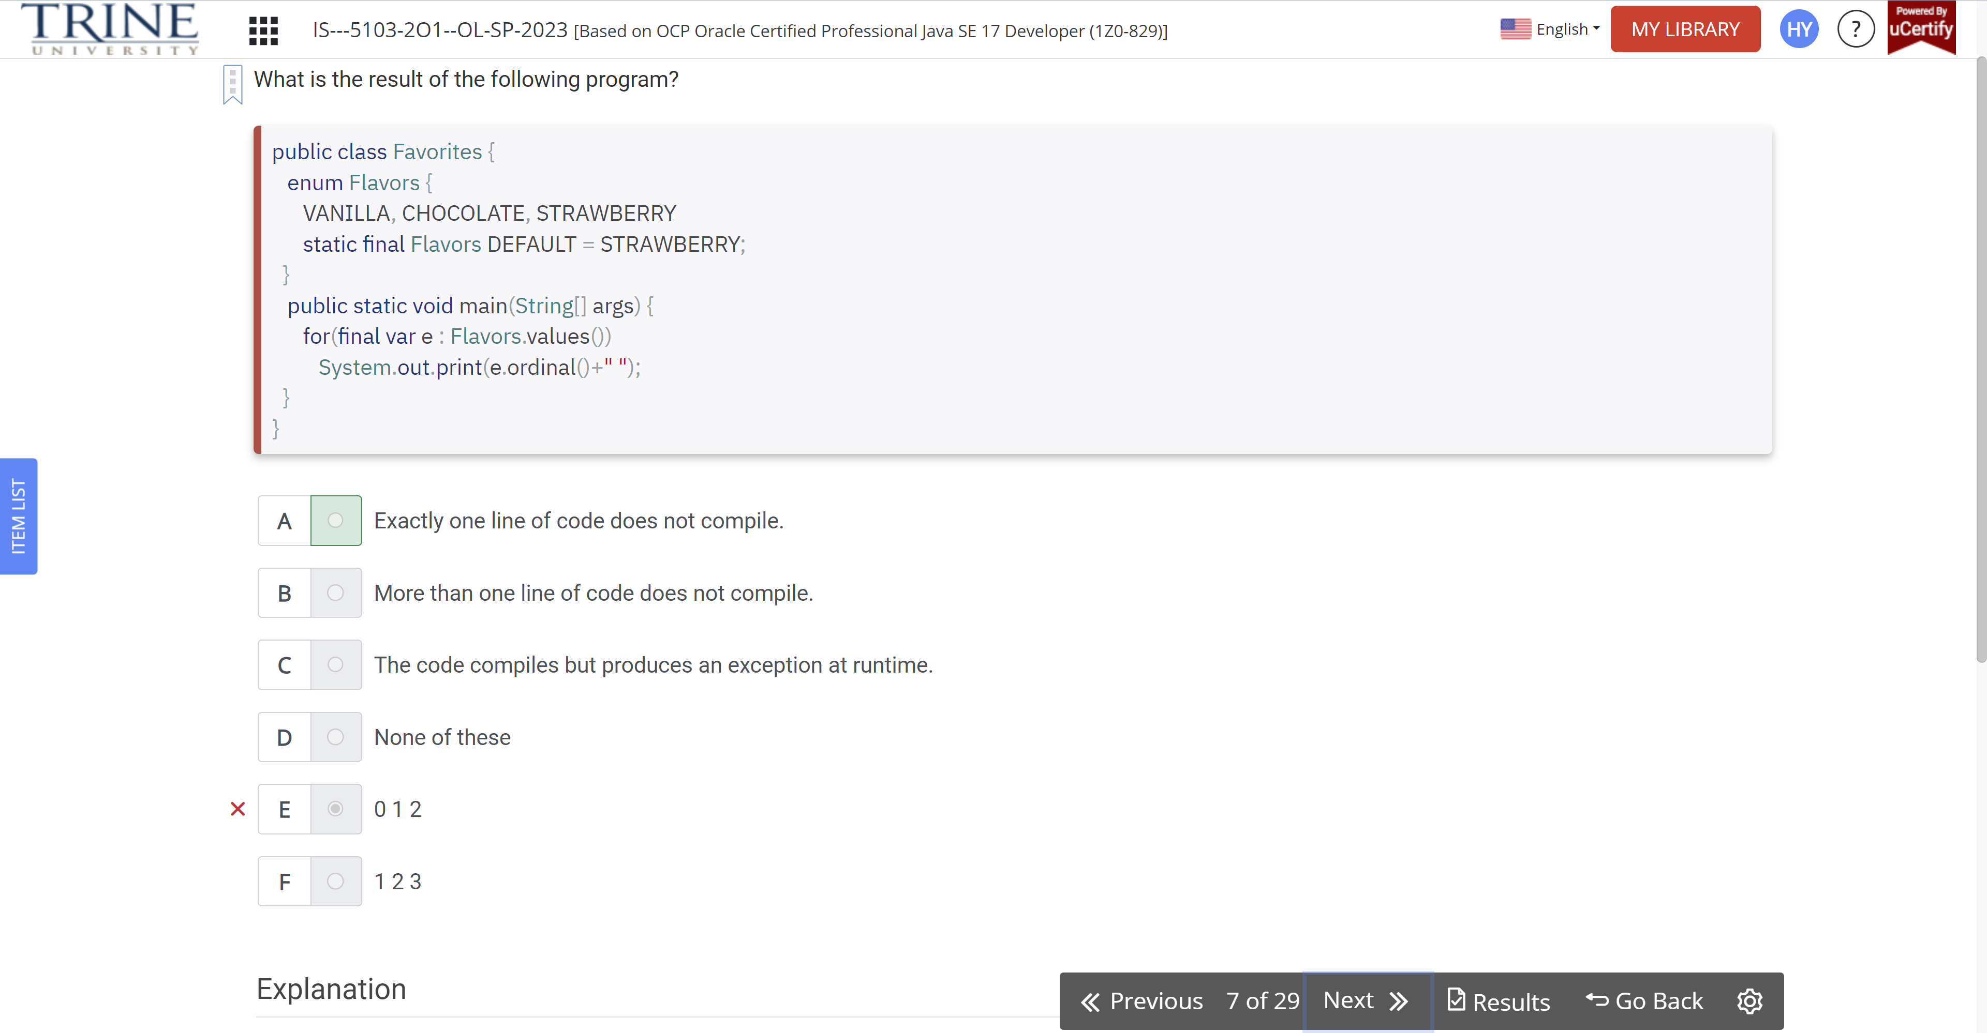

Which of the following can be inserted in the rest() method?

Public class Lion…

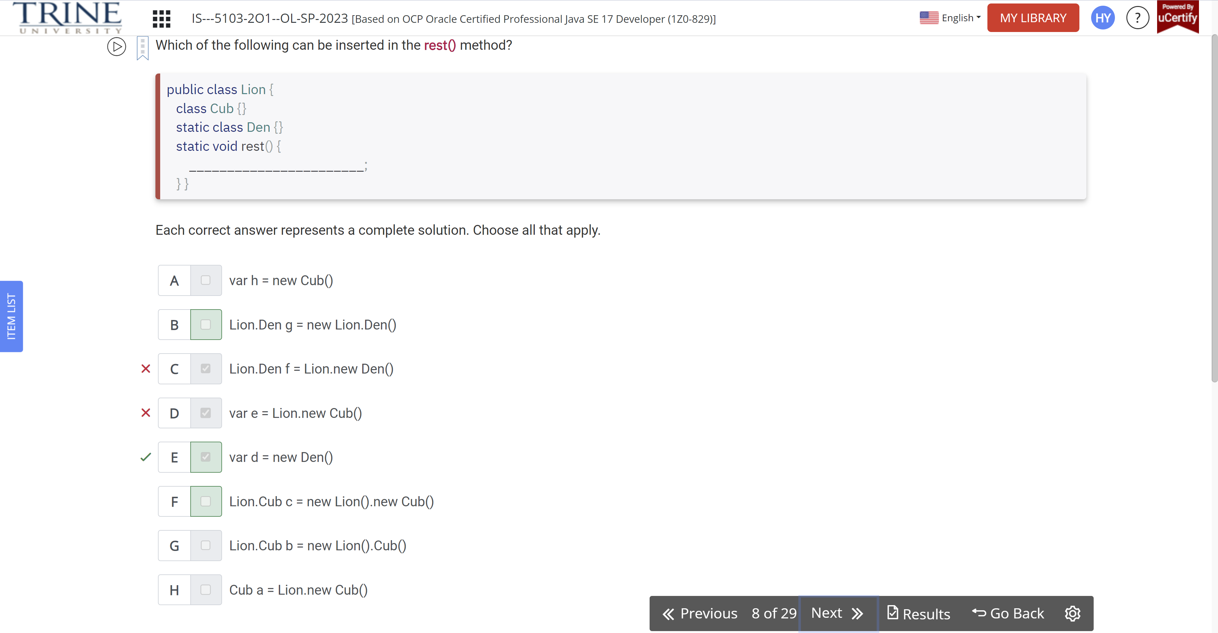

Which of the following classes and interfaces do not compile?

Public abstract class Camel {void travel();}

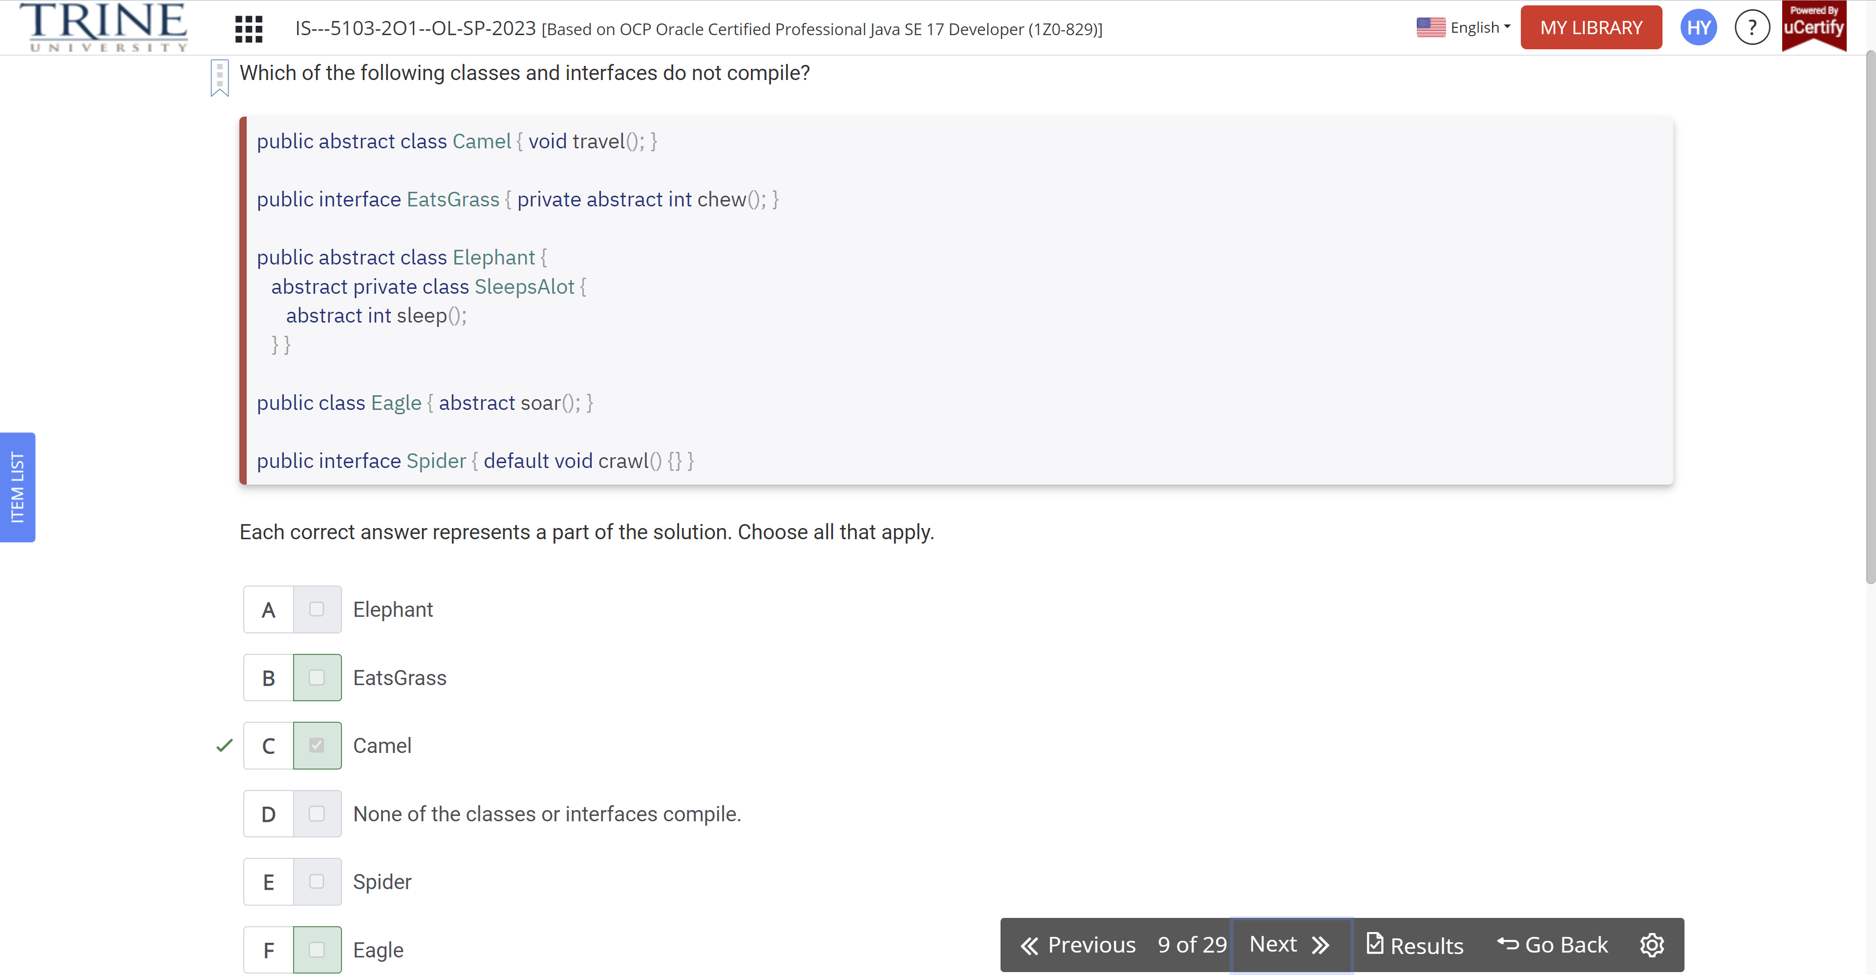

What does the following program print?

Public class Zebra…

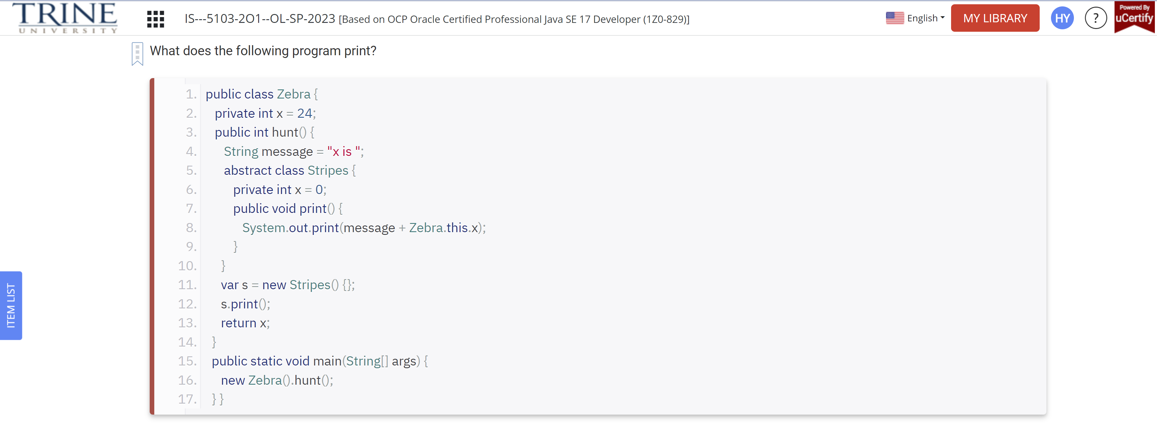

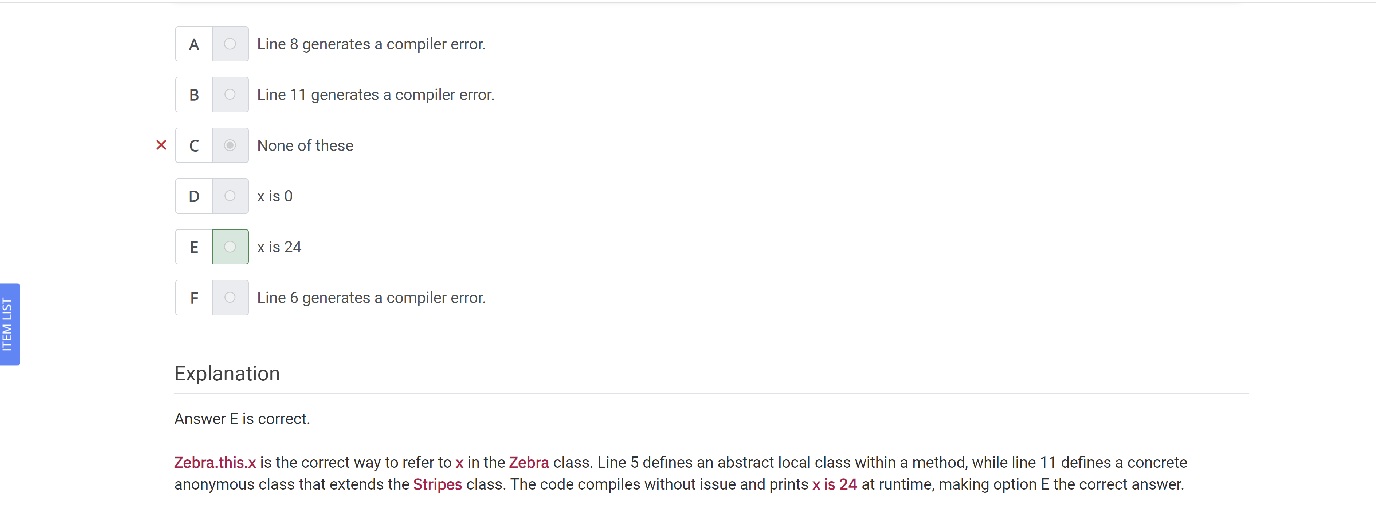

Which statements about the following program are correct?

Interface HasExoskeleton…

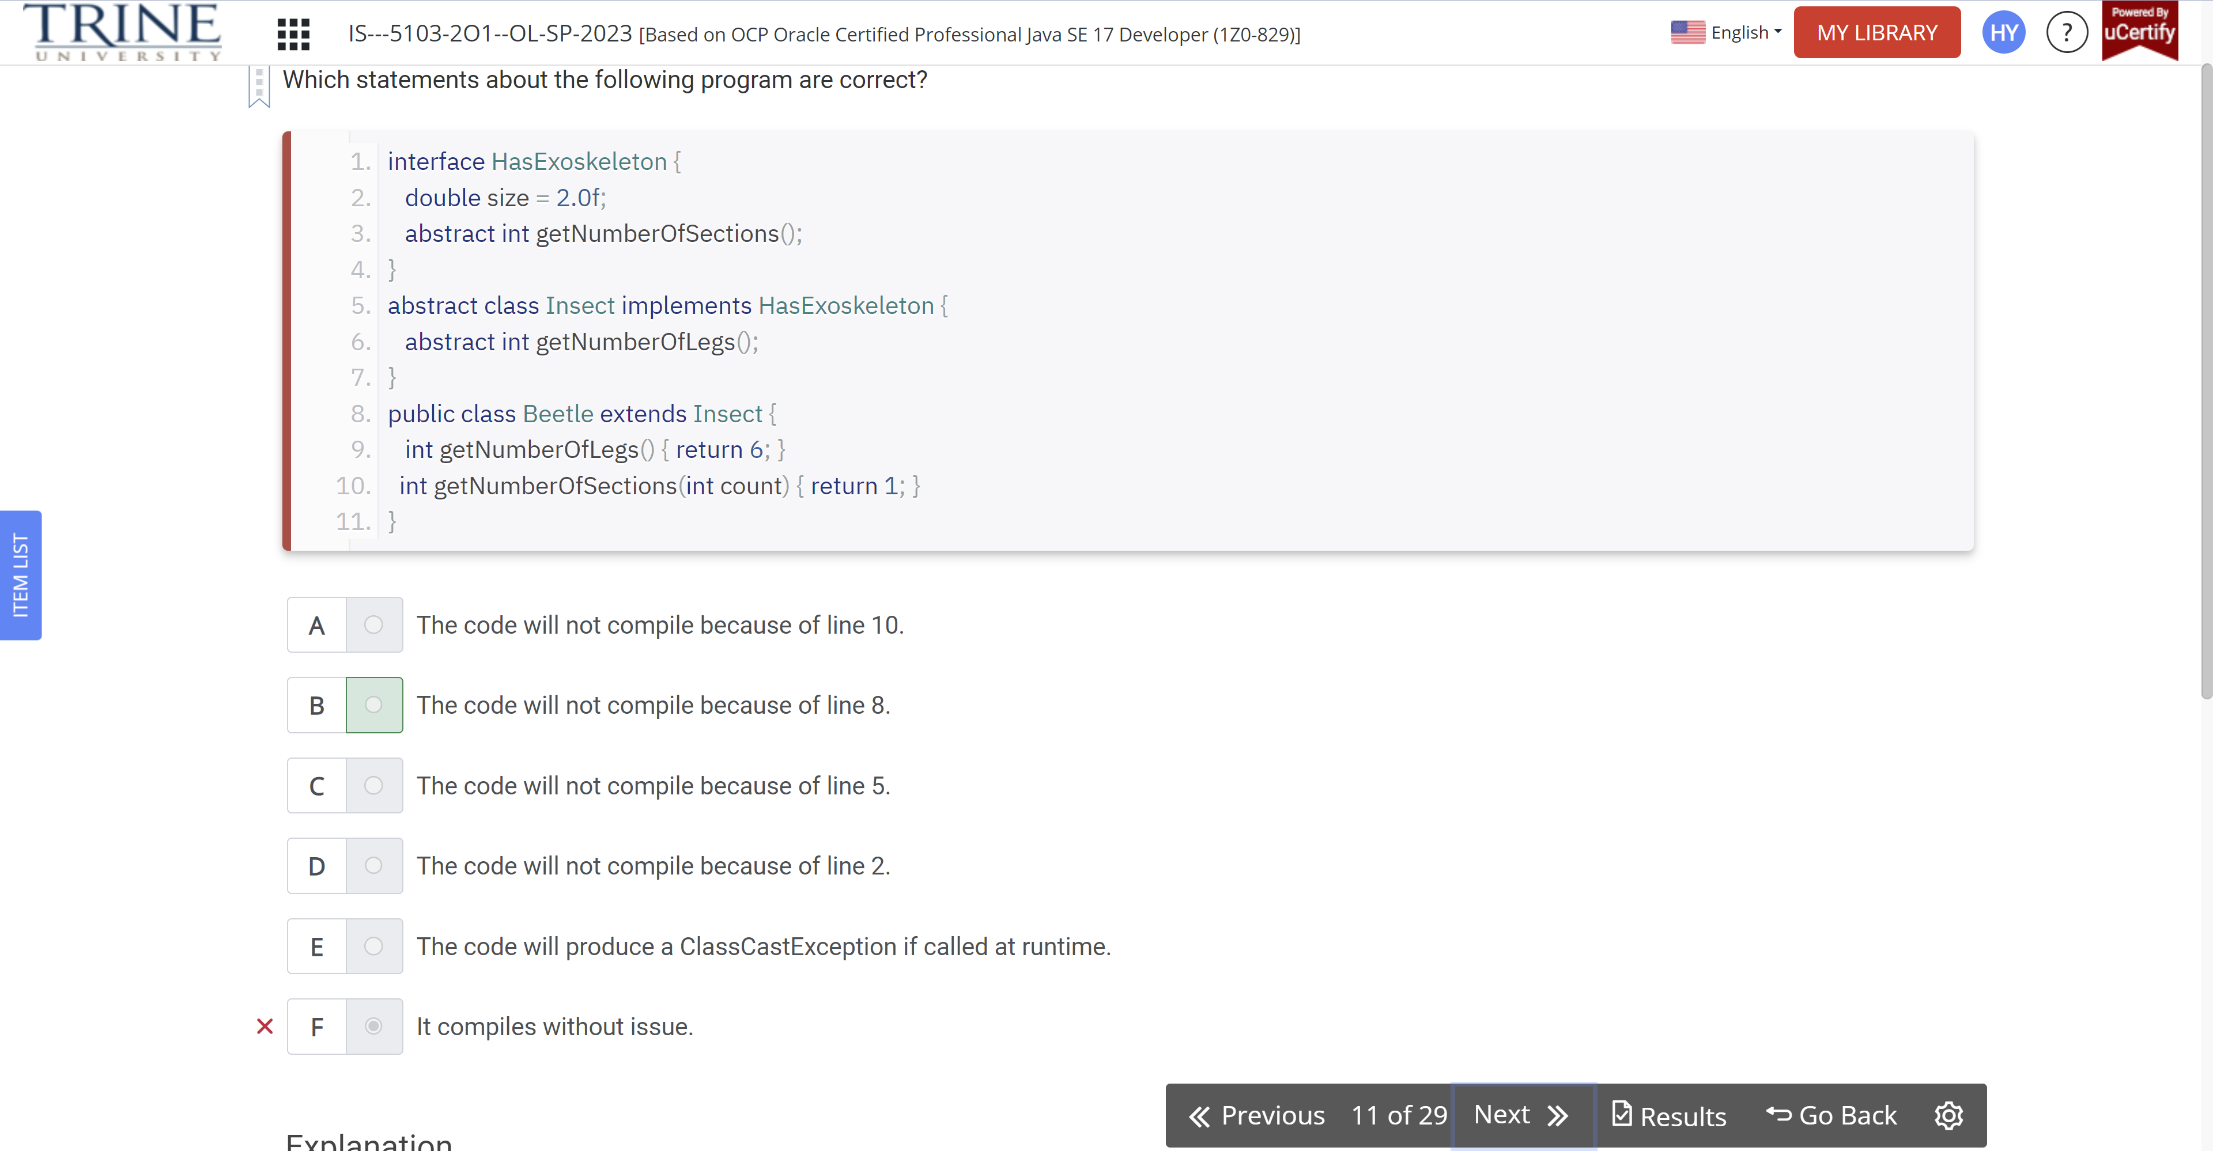

Which of the following statements can be inserted in the blank line so that the code will compile successfully?

Interface canHop..

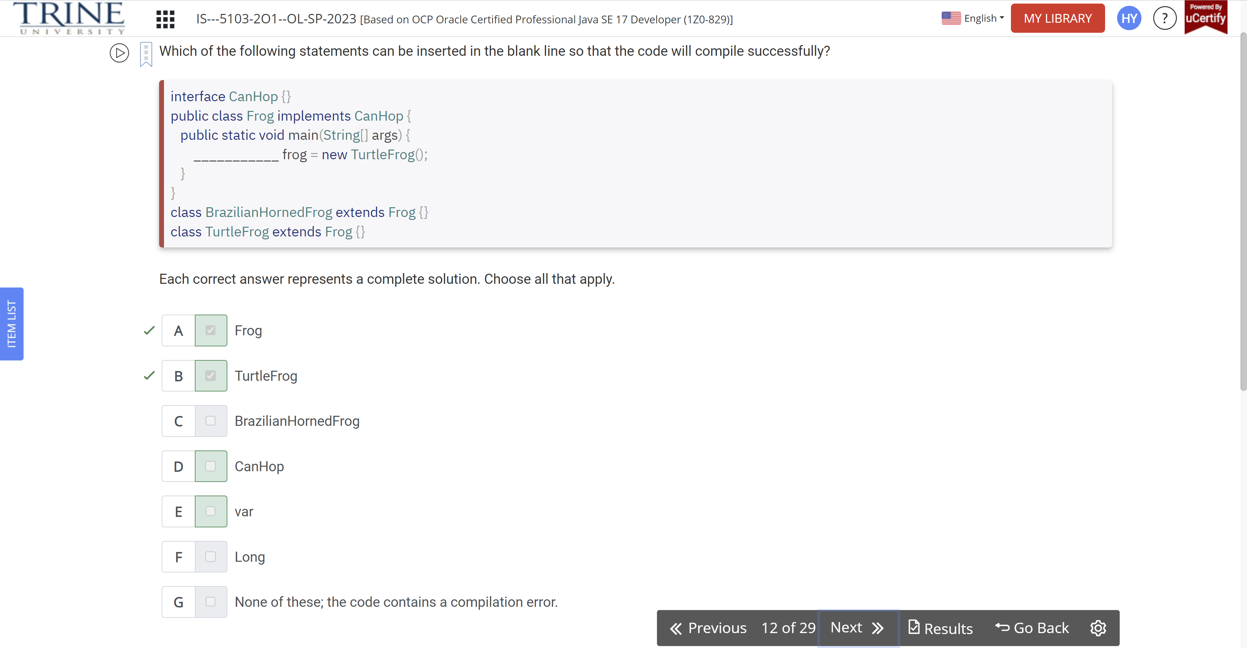

What is the output of the following program?

Public sealed class ArmoreAnimal permits Armadillo

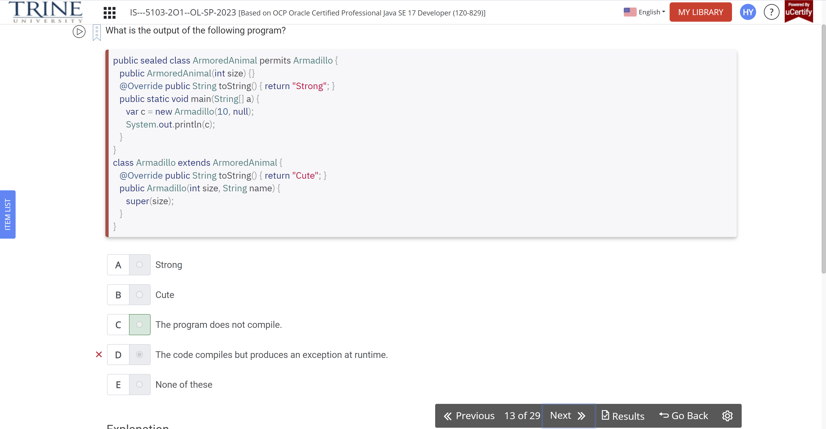

Assuming the following classes are declared as top-level types in the same file, which classes contain compiler errors?

Sealed class Bird…

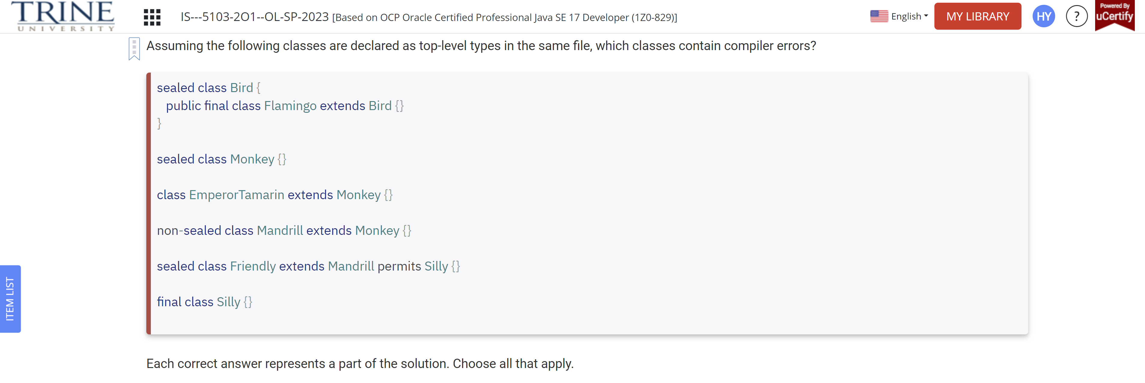

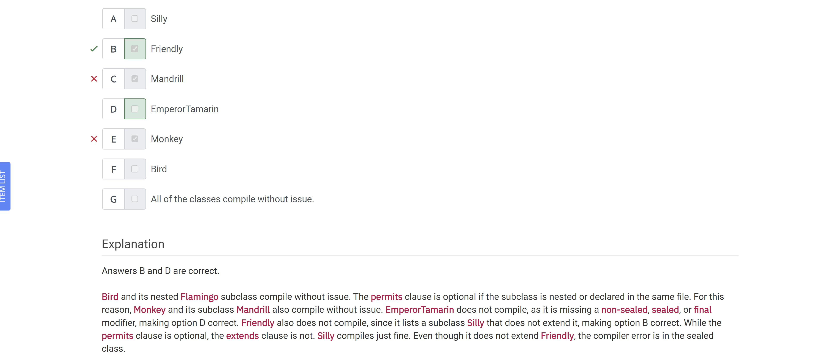

Which lines, when entered independently into the blank, allow the code to print Not scared at runtime?

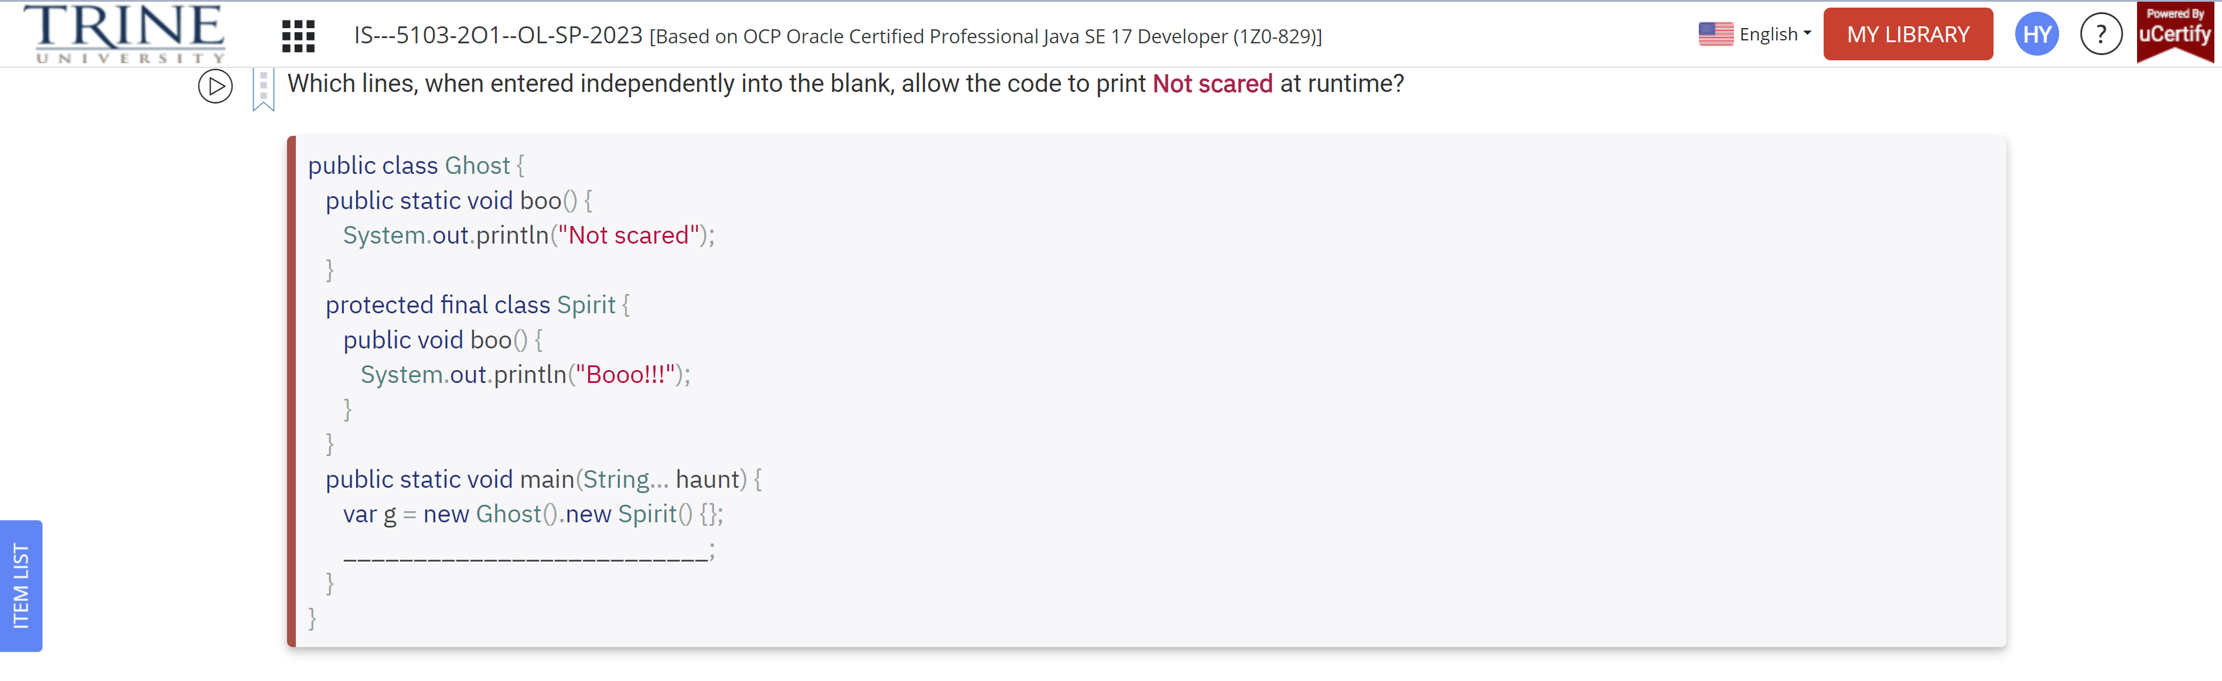

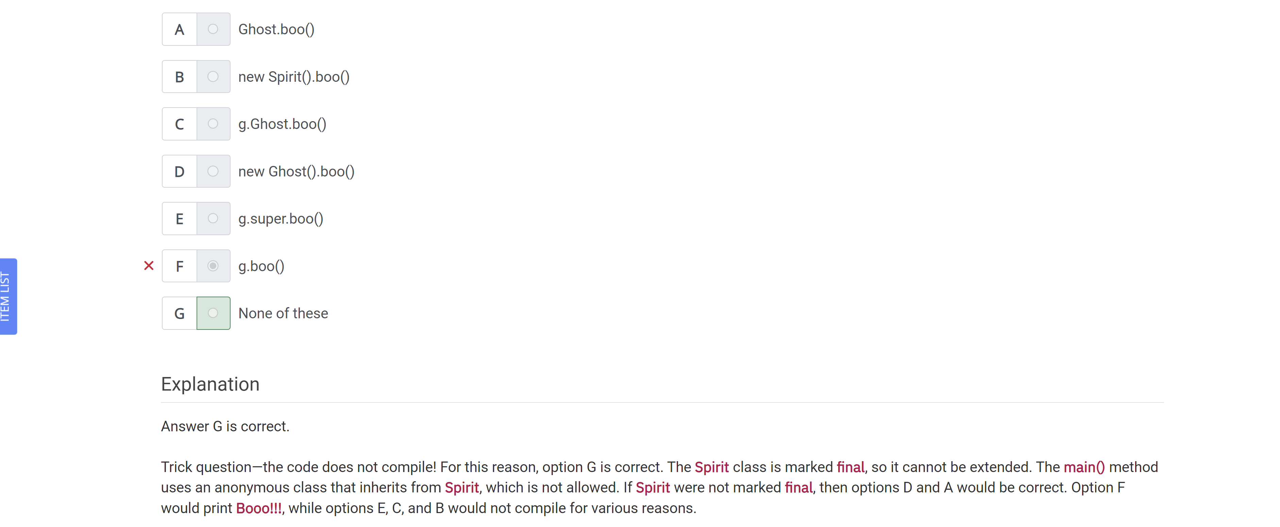

What is the result of the following program?

Public class Weather…

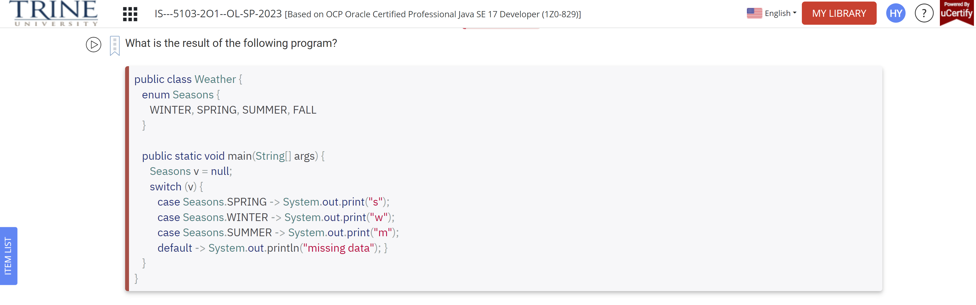

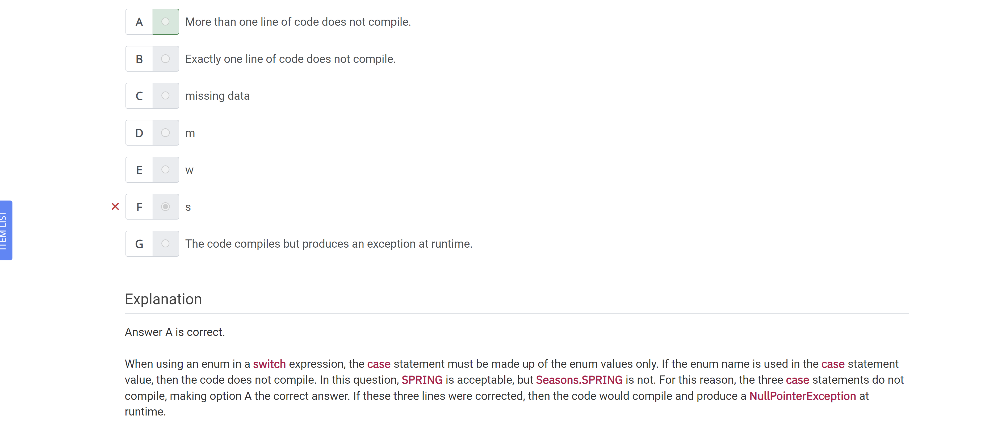

Given the following record declaration, which lines of code fill in the blank and allow the code to compile?

Public record RabbitFood(int size, String brand, LocalDate expires)..

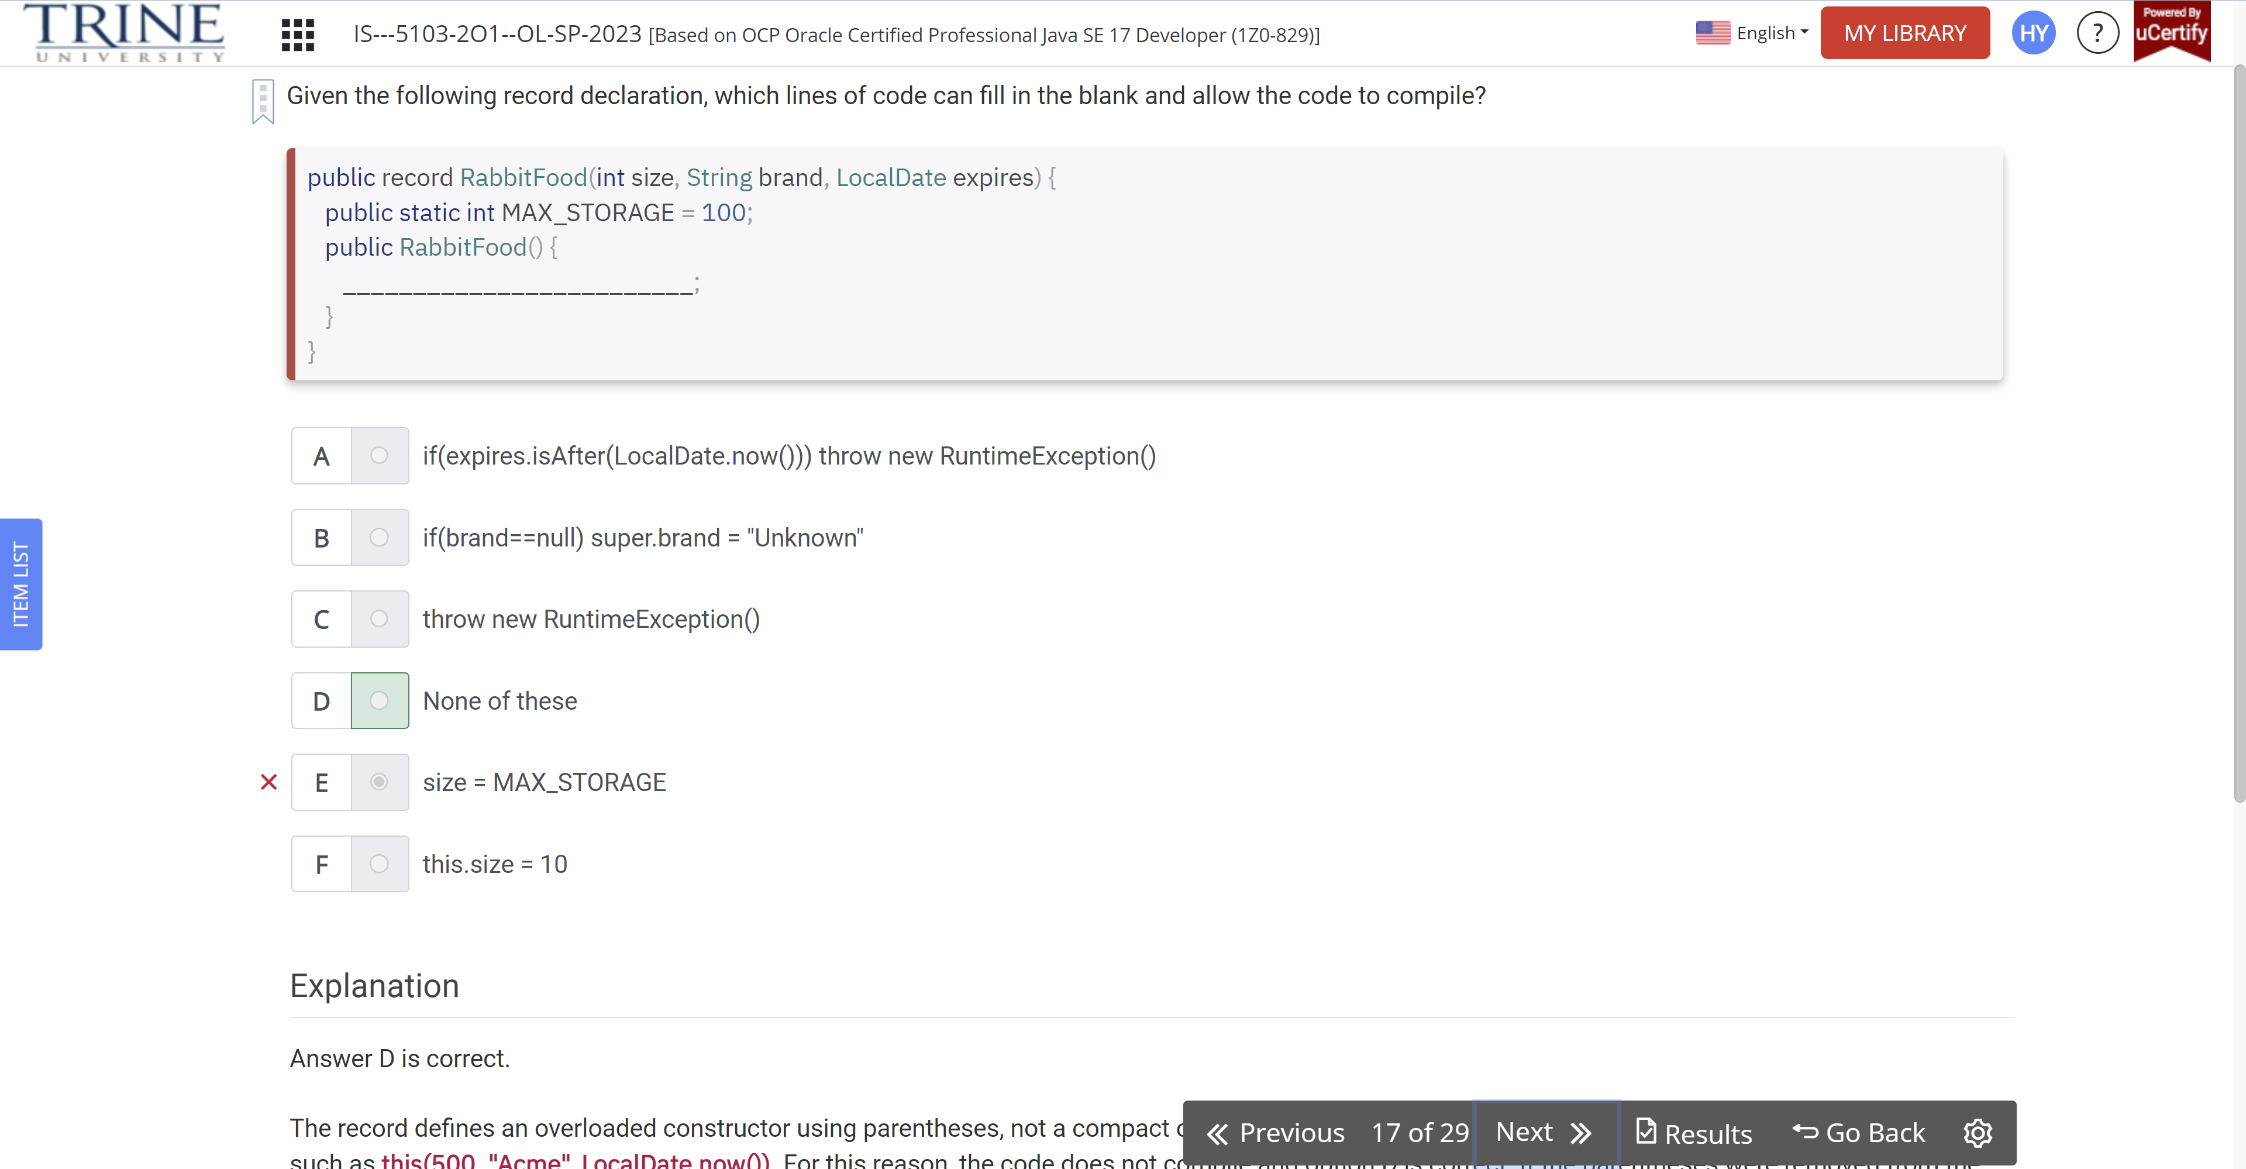

Which of the following are true about encapsulation?

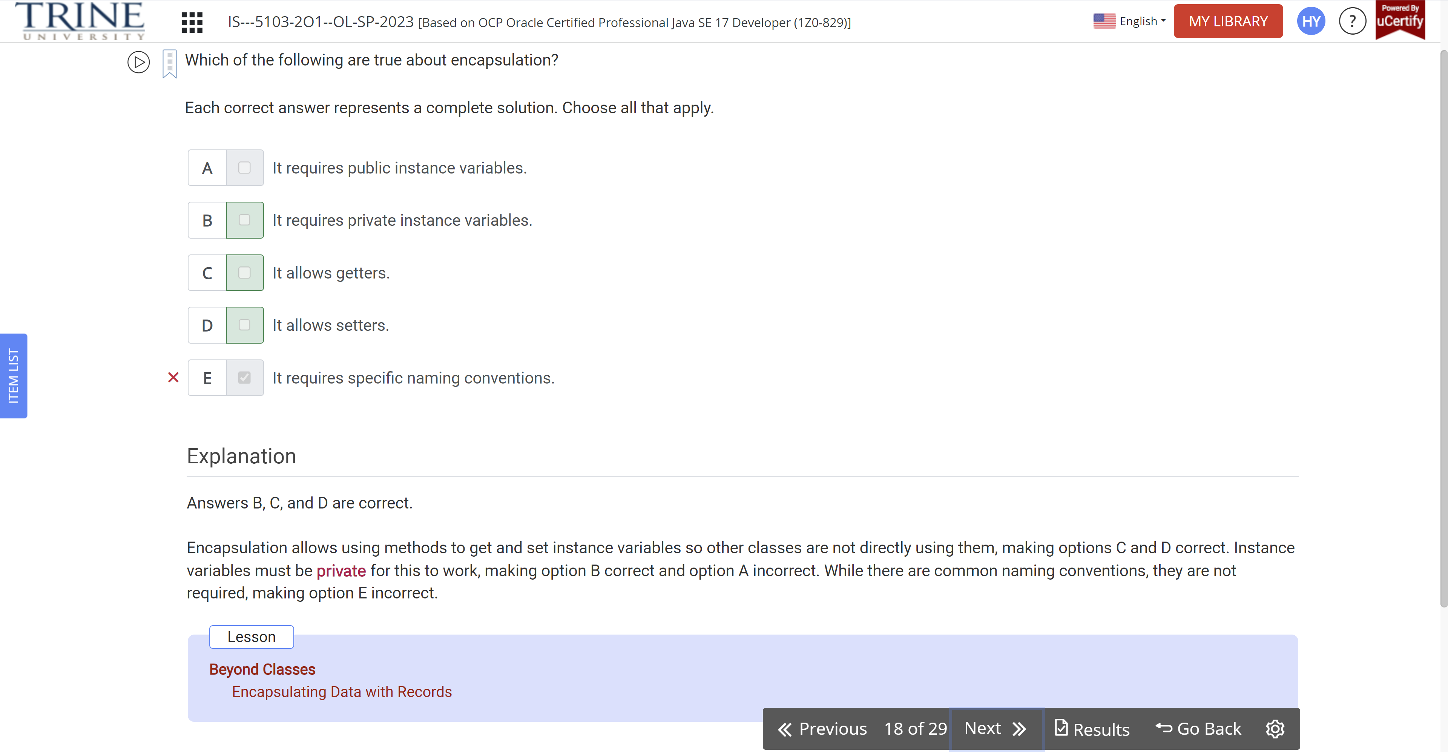

Which lines of the following interface do not compile?

Public interface BigCat…

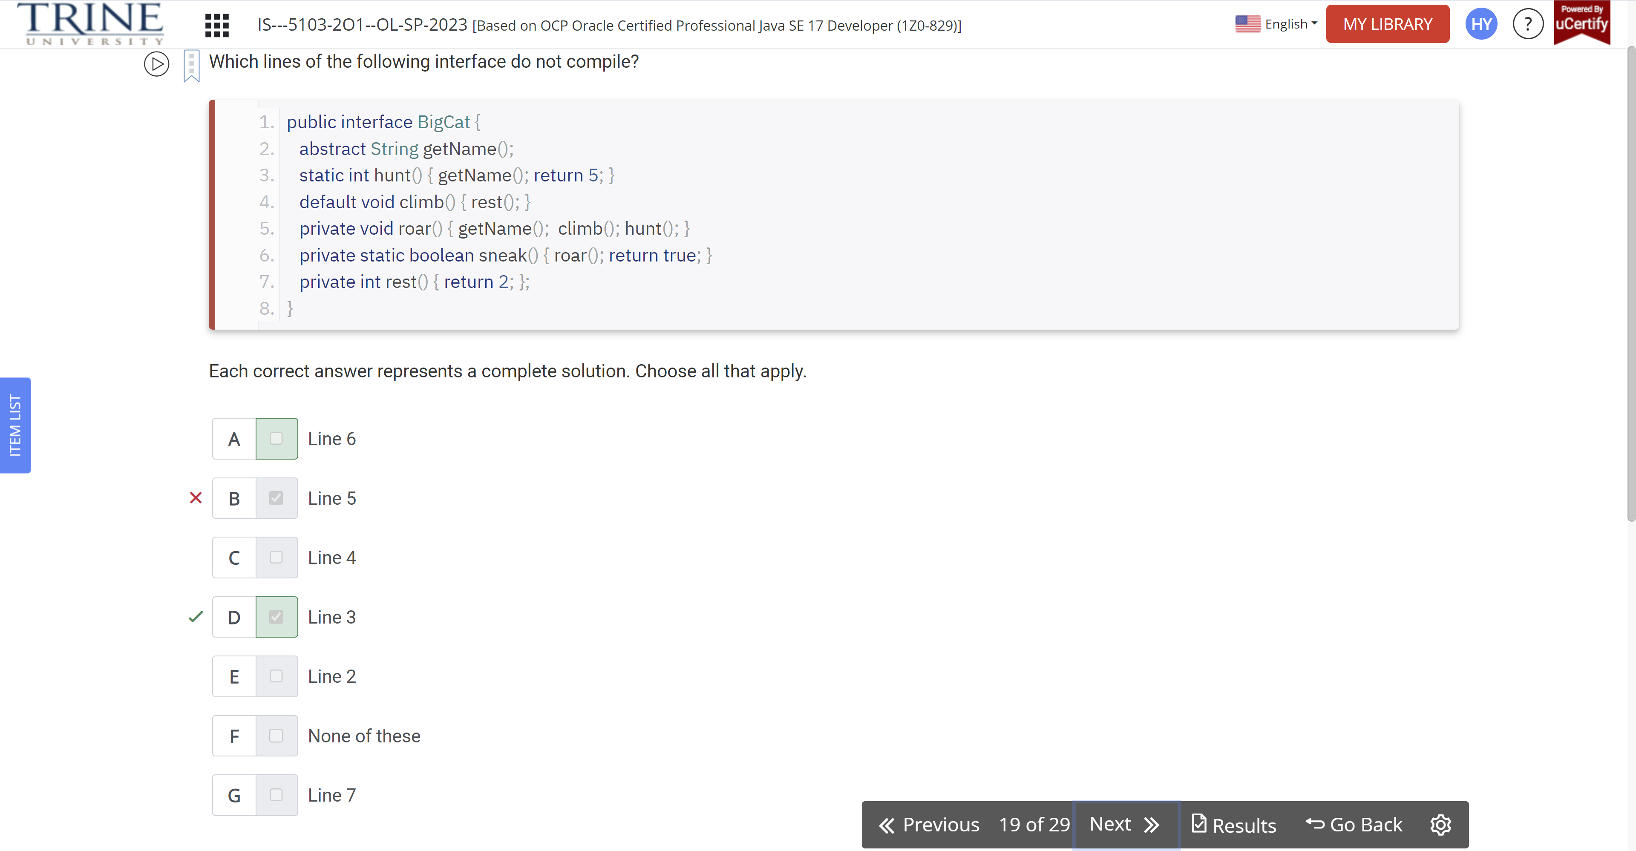

How many lines of the following program contain a compilation error?

Class Primate…

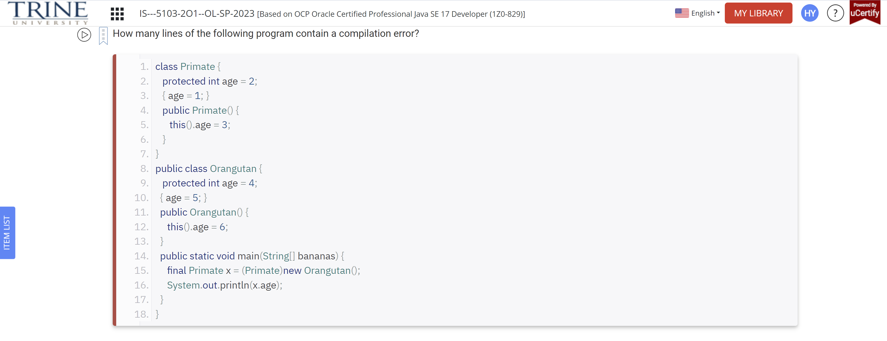

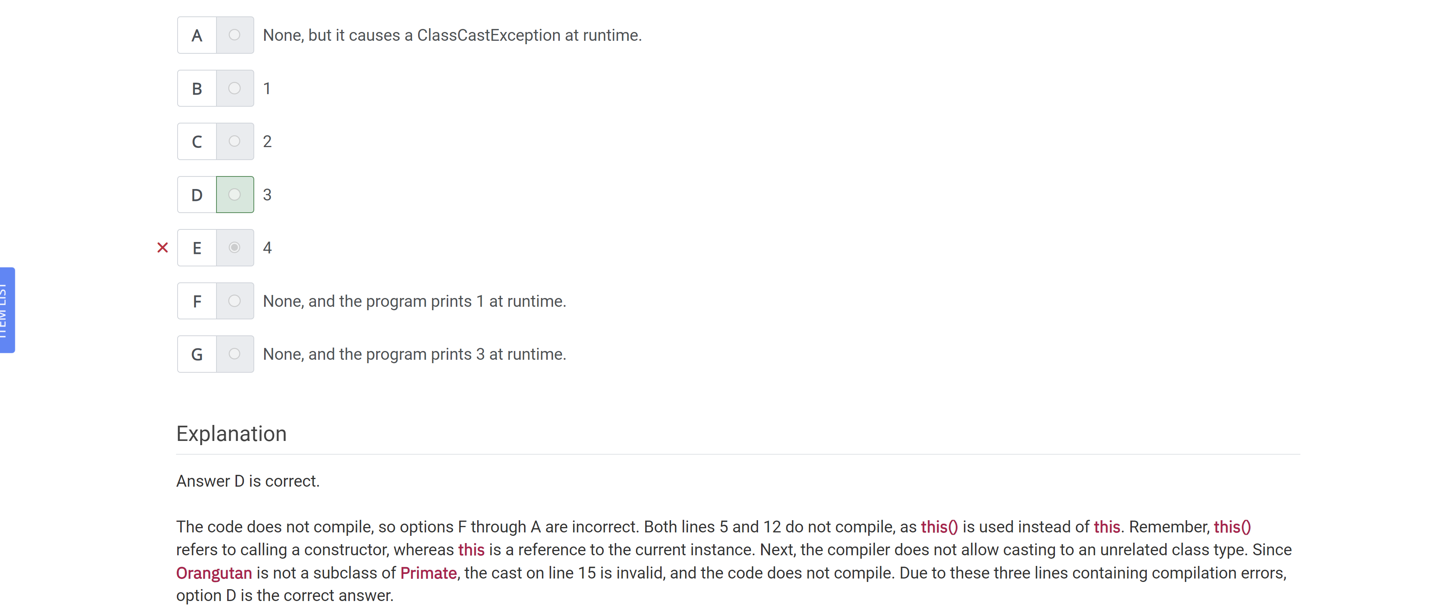

What is the result of the following Code?

Public class Movie…

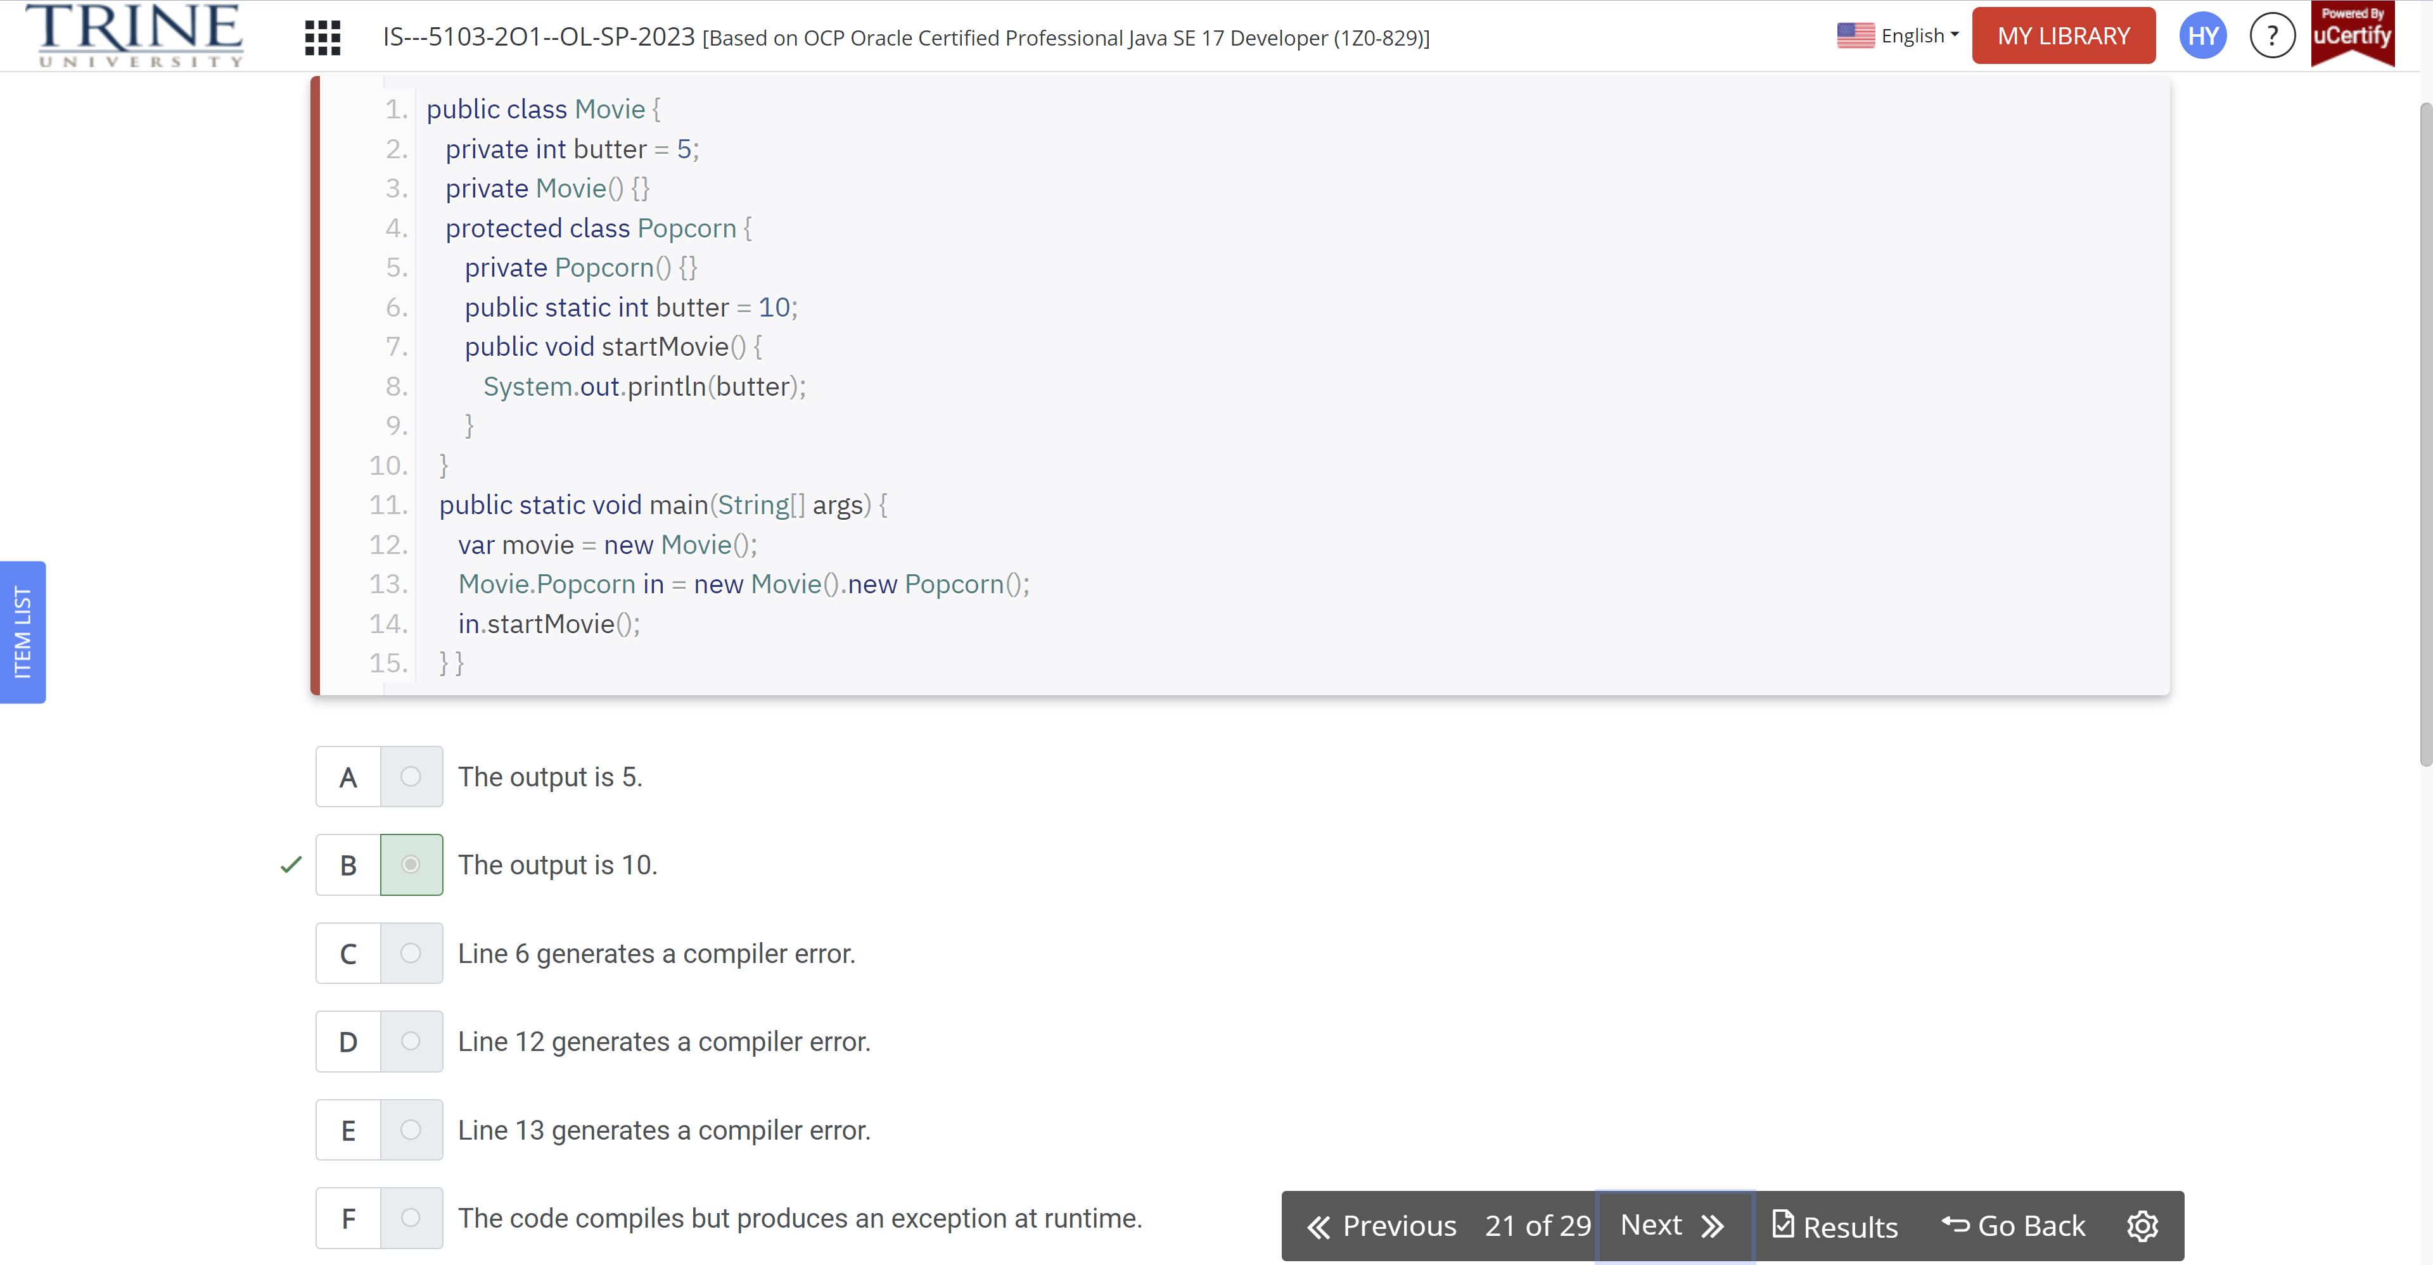

Which of the following are printed by Bear program..

Public class Bear…

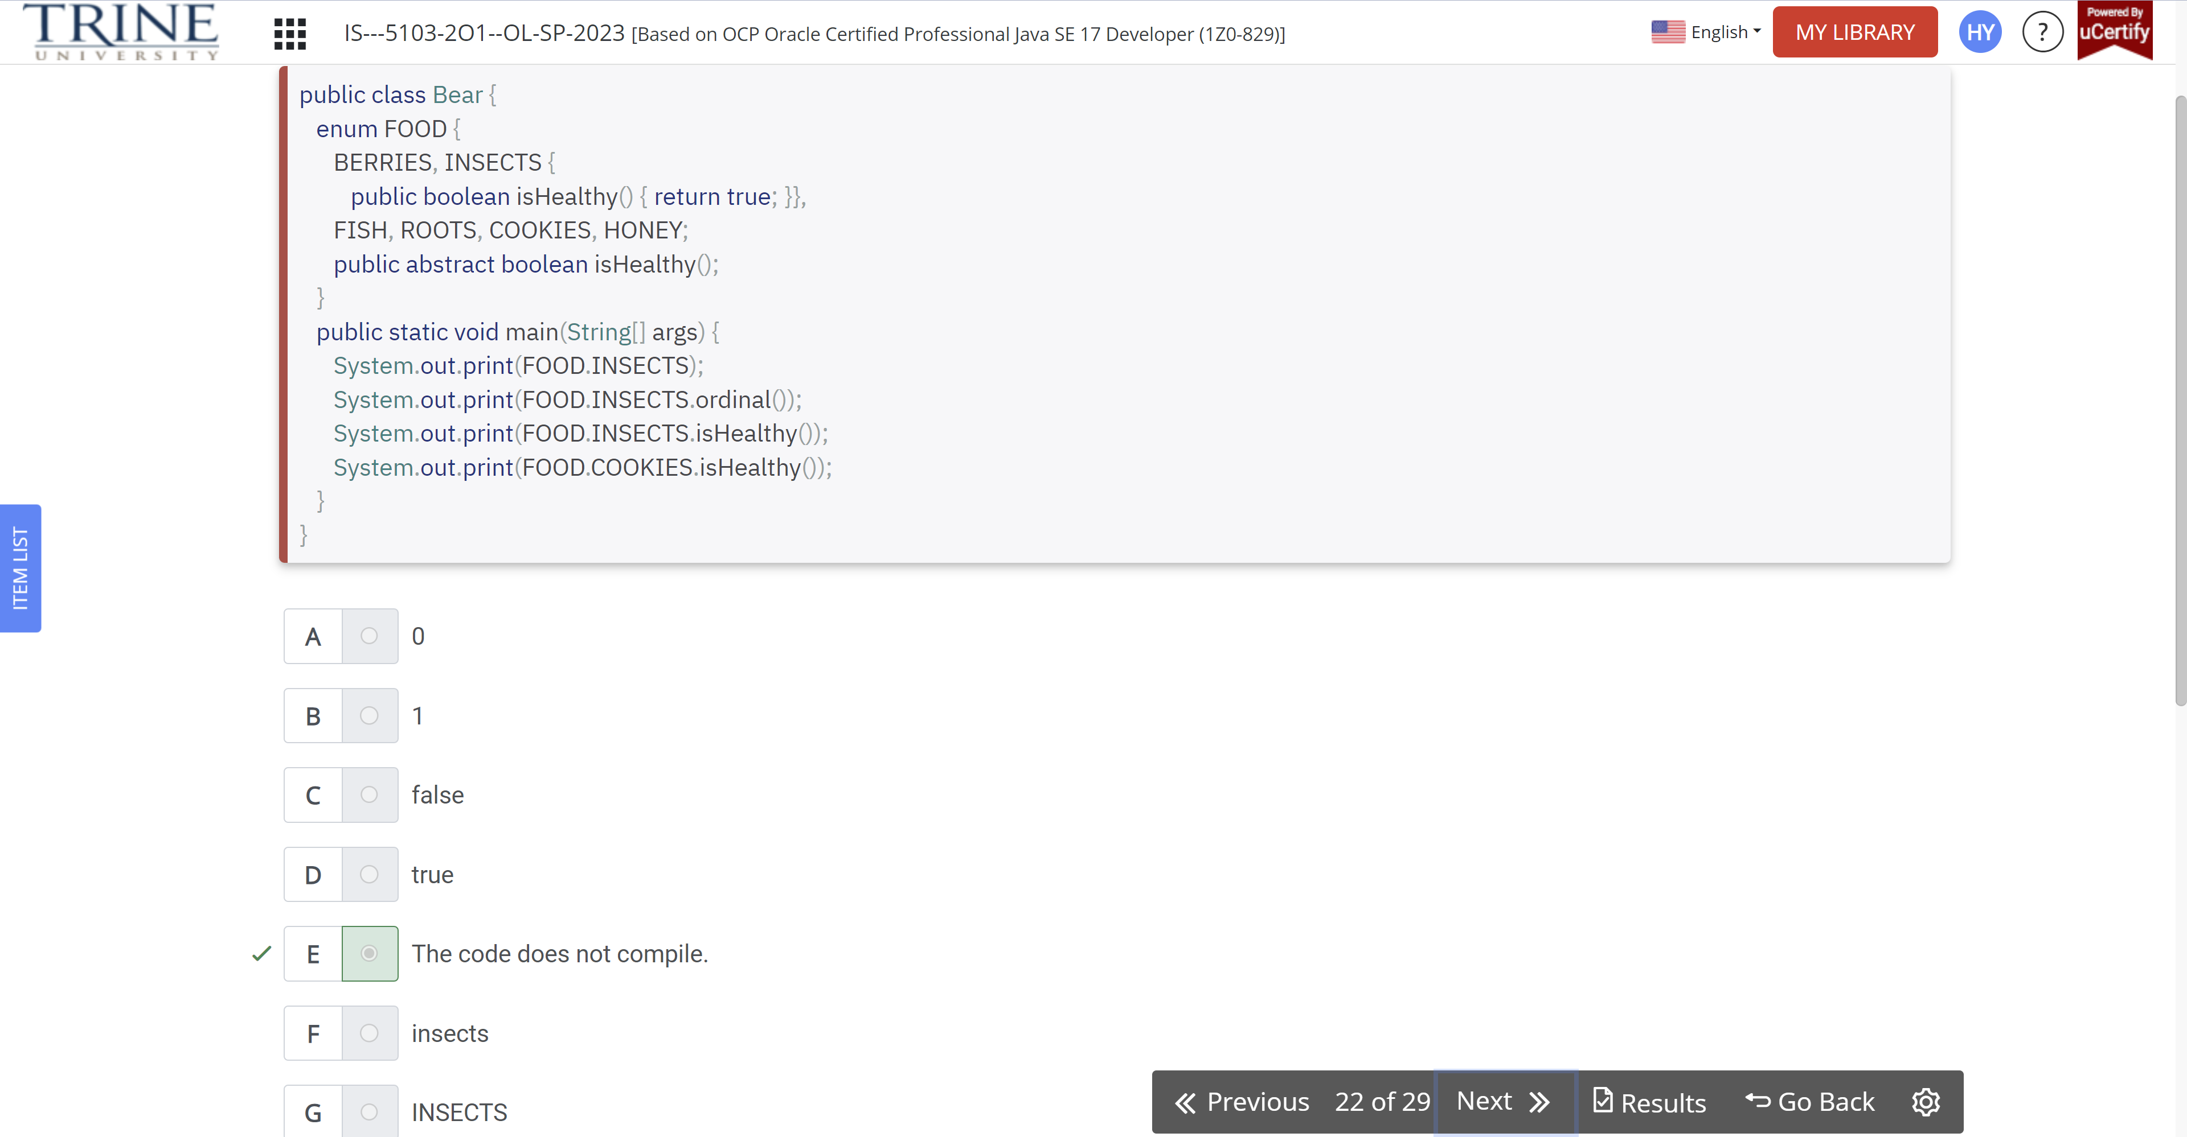

What types can be inserted in the blanks on the lines marked X and Z that allow the code to compile?

Interface Walk…

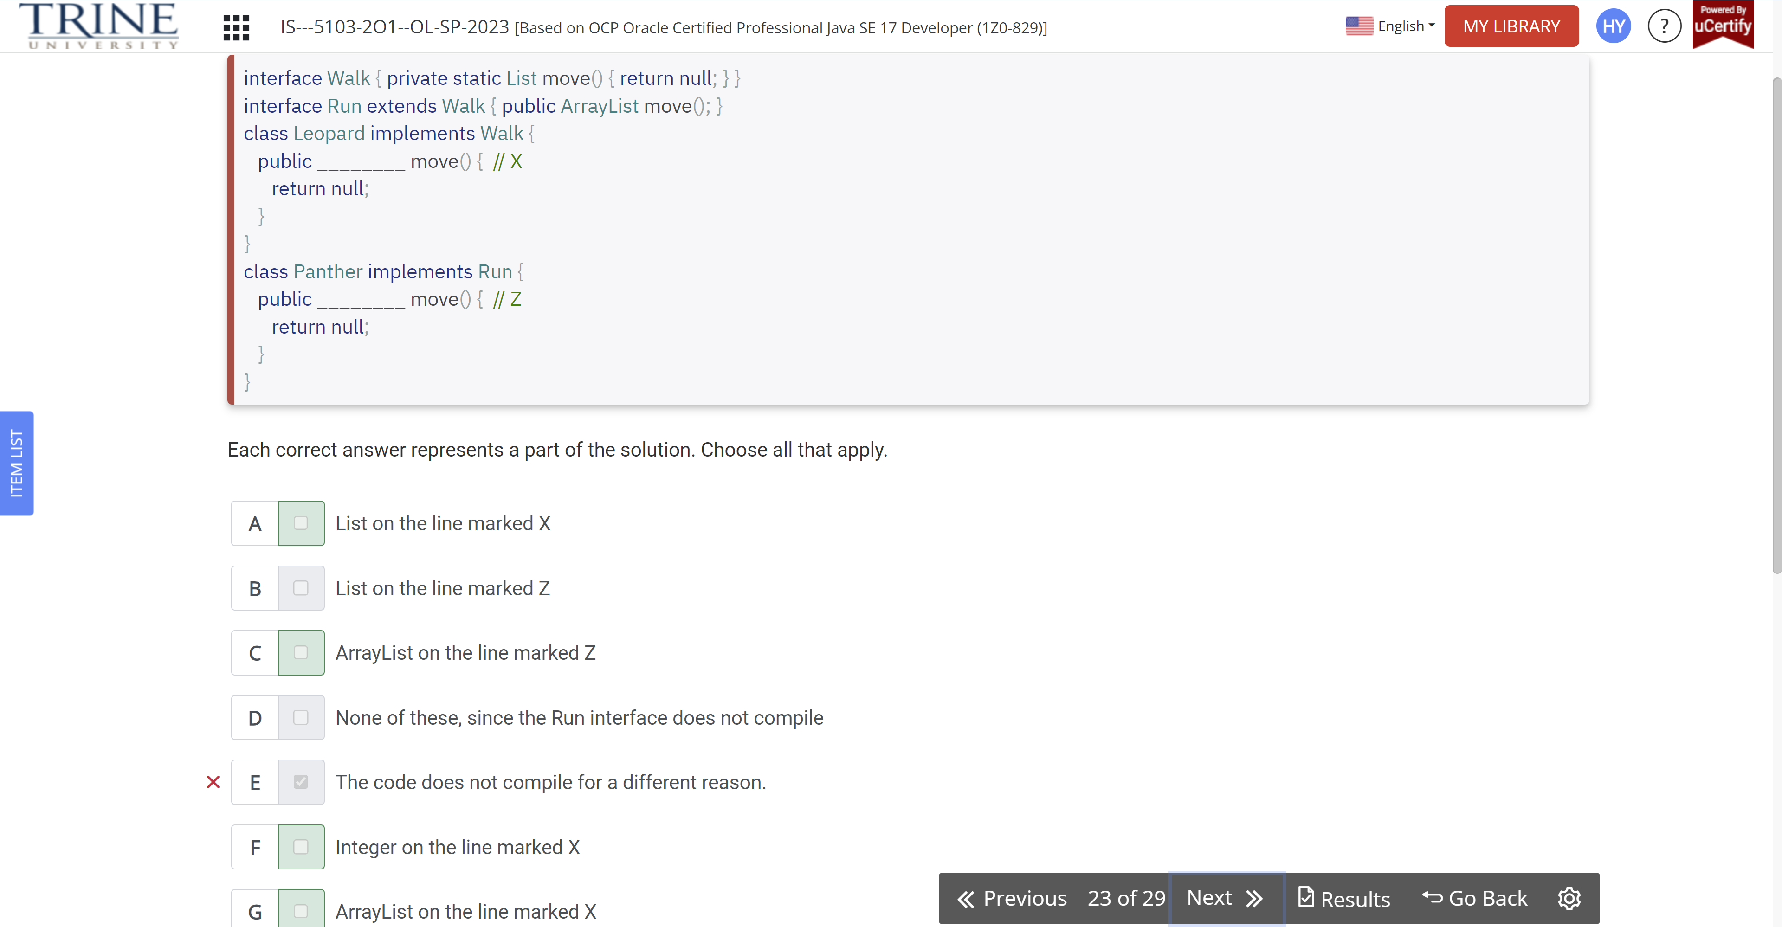

Which statements about the following enum are true?

Public enum Animals…

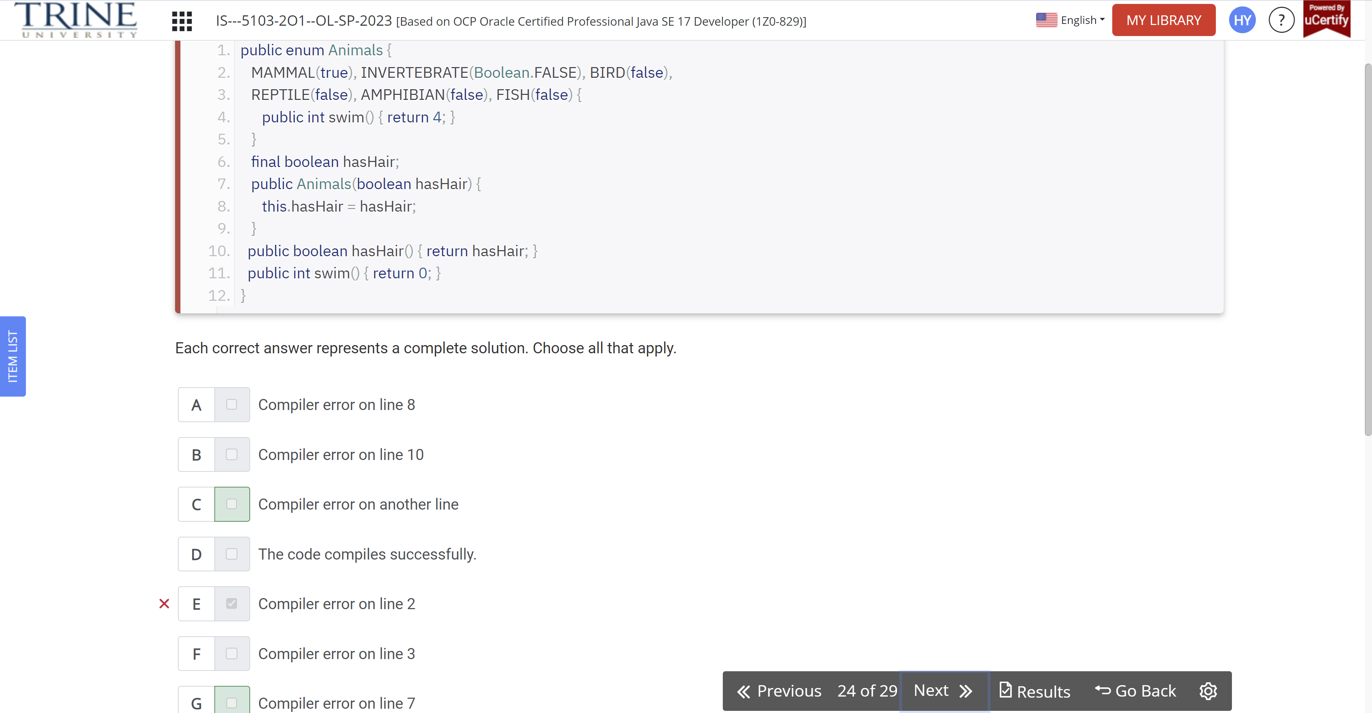

Given the following program, what can be inserted into the blank line that would allow it to print Swim! At runtime?

Interface Swim…

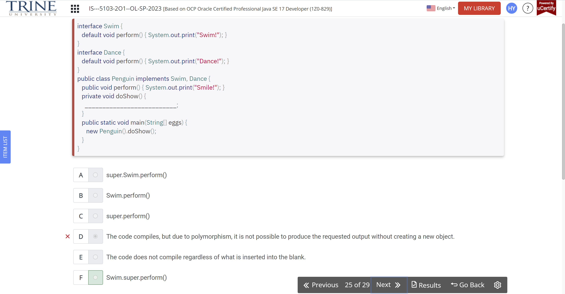

The following code appears in a file named Ostrich.java. What is the result of compiling the source file?

Public class Ostrich….

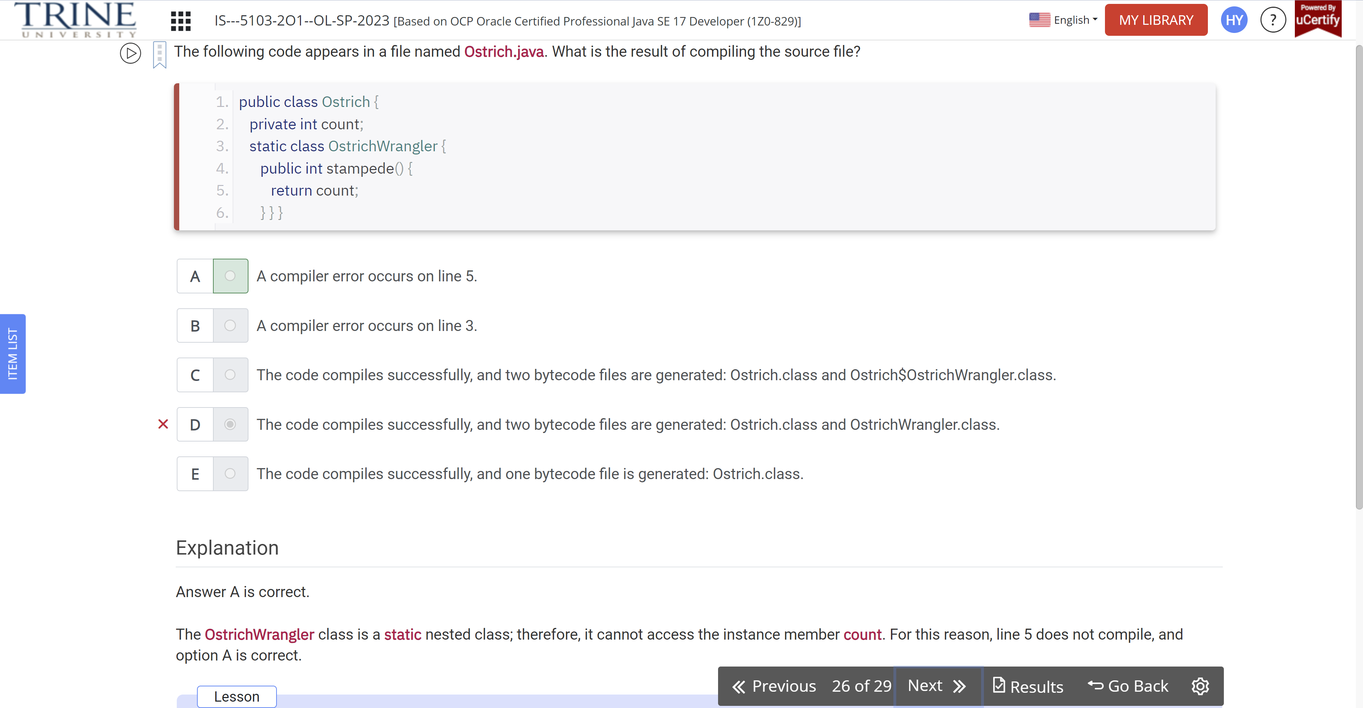

When inserted in order, which modifiers can fill in the blank to create a properly encapsulated class?

Public class Rabbits…

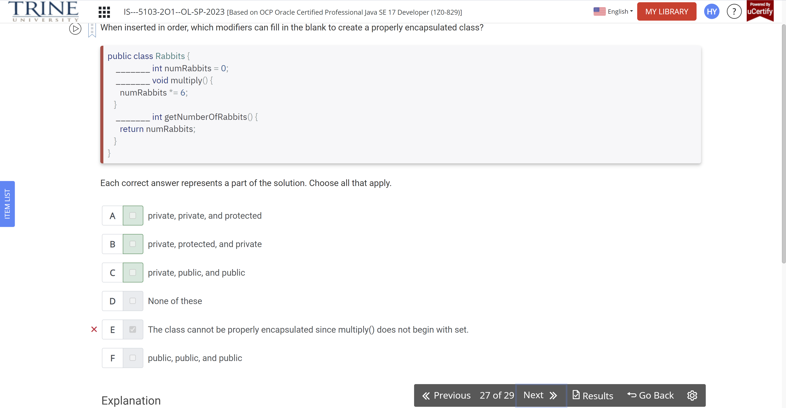

Which statements about polymorphism and method inheritance are correct?

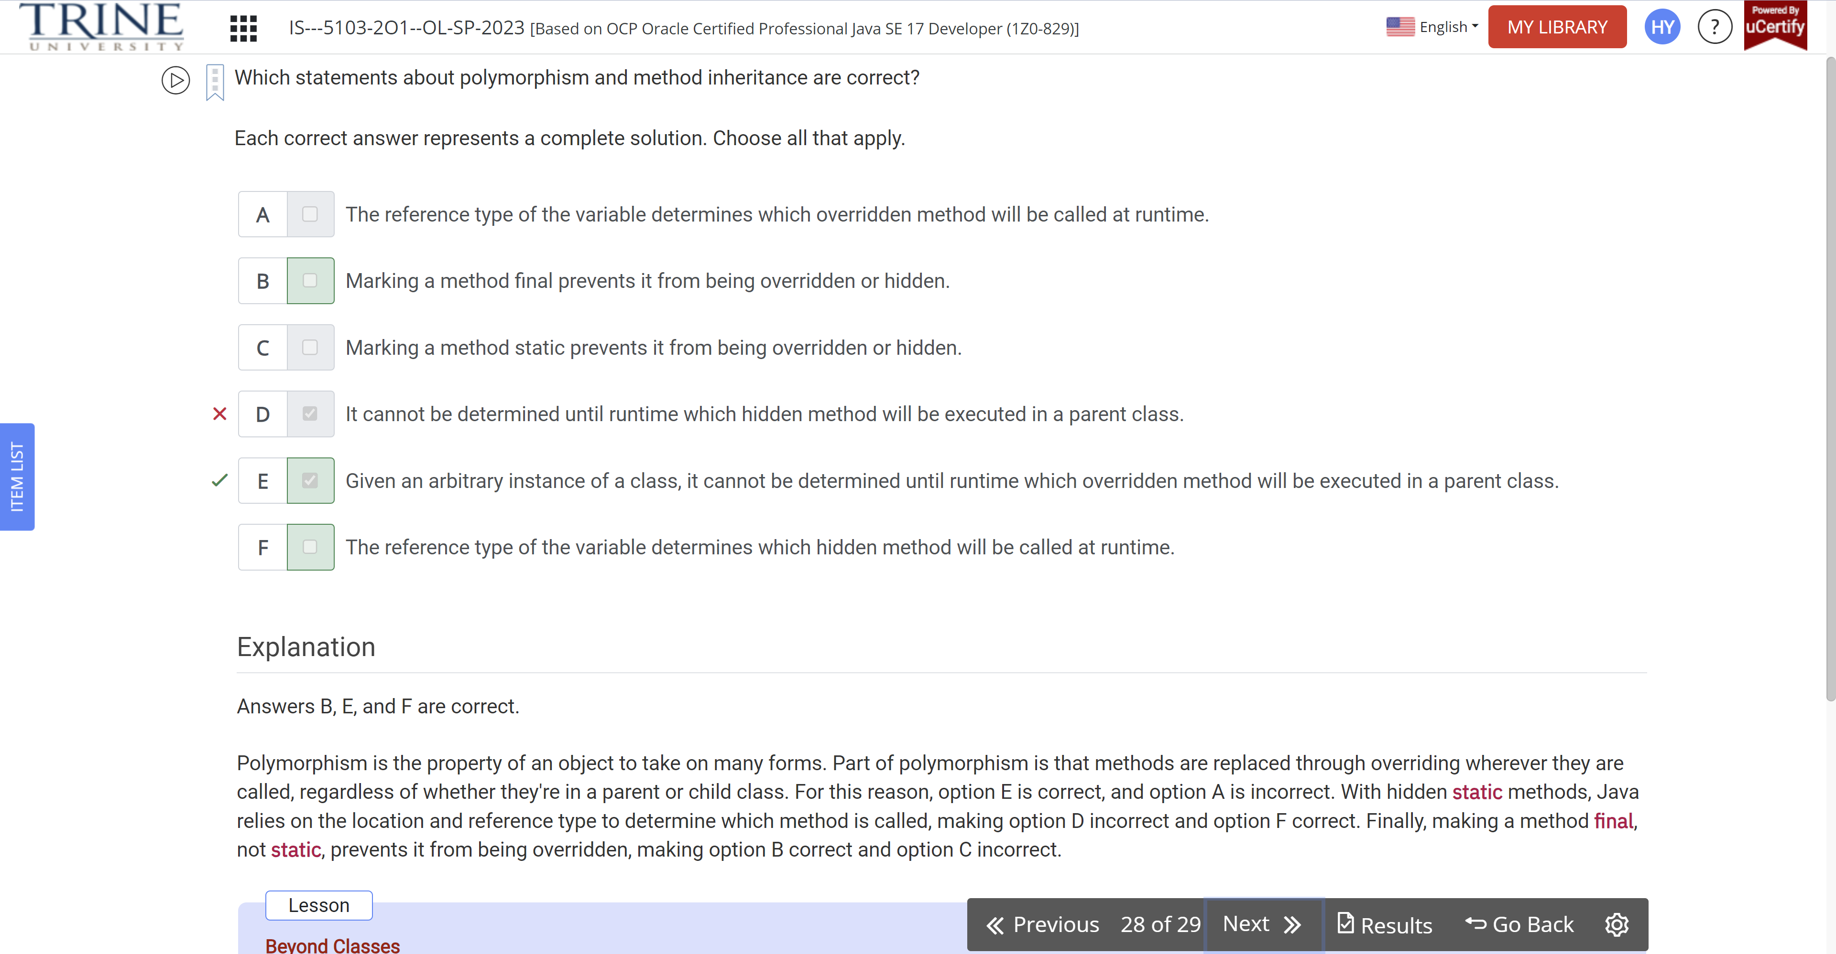

What is printed by the following program?

Public class Deer…

